**CHEG 432 - Chemical Process Analysis II**

**Methyl Acetate Manufacture - Design and Optimization**

**Group T**

Gavin Guerrera

Adarsh Kannan

Abdul Fayeed Abdul Kadir

**Project Advisors:** Prof. Christopher Roberts and Prof. Bert Diemer

May 12th, 2022

**Table of Contents**

Executive Summary 3

Introduction 4

Route Selection 4

Route overview 4

Preliminary economic considerations 5

Final selection 6

Route Optimization 7

Reactor 7

Recycle and separation structure 9

Overview of final BFD 9

Materials of construction 10

Heat integration 11

Economic Analysis 12

BOE Equipment sizing 12

Equipment costing 12

Transfer Price Determination and NPC, NPV and IRR Evaluations 13

Sensitivity Analysis 16

Risk Assessment 20

Chemical safety 20

Operations safety 21

Carbon tax 22

Conclusions 22

References 23

Appendices 24

Appendix A: Detailed Block Flow Diagram of Esterification Process 24

Appendix B: Initial Block Flow Diagram for Carbonylation Process 26

Appendix C: Calculating the NROI 29

Appendix D: Kinetics of MeOAc Production 30

Appendix E: Calculations for Energy/Heat Integration 31

Appendix F: Determination of Heat Exchange Area 37

Appendix G: Determining the Length and Diameter of the Flash Tank 38

Appendix H: Computing the Purchase Cost of Heat Exchanger 39

Appendix I: Computing the Purchase Cost of Distillation Column/Vertical Pressure Vessel 40

Appendix J: Computing the Purchase Cost of Compressor 41

Appendix K: Computing the Purchase Cost of Fired Heater 42

Appendix L: Venture Guidance Appraisal Spreadsheet 43

Appendix M: Variable Costs Breakdown Detailed Calculations 44

Appendix N: Net Present Values Spreadsheet 47

Appendix O: MATLAB Codes for Sensitivity Analysis 48

Appendix P: Carbon Tax Scenario as One of the Risk Assessments 54

Appendix Q: Final Stream Table Values 56

Appendix R: Temperature, Pressure Conditions for final case 57

Appendix S: Aspen Screenshot for reference 58

Appendix T: Cost of Manufacture Spreadsheet 60

**Executive Summary**

This report provides an engineering and economic overview into the production of a 375 MM pound per year methyl acetate plant, which would be utilized alongside a 500 MM pound per year acetic anhydride plant. The transfer price at a net return on investment (NROI) of 25% is $1,126/tonne, with the associated net present cost (NPC), venture guidance appraisal (VGA) and cost of manufacturing (COM) being $300MM, $63MM, and $21MM respectively. The transfer price obtained is below the price provided by the DMAC recovery plant of $1520/tonne, thus indicating the economic feasibility of the project.   
  
 To reduce economic costs, several optimization strategies were carried out, including justification of route, reactor and separation structure optimization, followed by heat integration to reduce utility costs. The carbonylation route was chosen over the esterification route, due to the higher raw material cost associated with acetic acid, when compared to those of methanol and carbon monoxide. Furthemore, acetic acid corrodes carbon steel, and hence stainless steel materials need to be used for the esterification process. The H-mordenite catalyst was utilized as opposed to the ion-exchange resin due to the lower catalyst mass and reactor costs associated with the former. The separation structures and reactors were run at higher pressure and temperature conditions to minimize manufacturing costs while maximizing reactor and separation efficiencies. Finally, heat integration was carried out to reduce utility costs.

After performing the sensitivity analysis, it was found that the variations in the production rate, VGA, tax rate, the prices and yield of MeOH, CO, and H2, and the operator’s wage have significant effects on the changes in transfer price of MeOAc. By taking this into consideration, Monte Carlo simulations were carried out and it was found that the transfer price would vary between $200/tonne to $2,100/tonne. Thus, in certain circumstances, the transfer price could exceed the price set by the DMAC plant ($1,520/tonne).

**Introduction**

Our company is a major manufacturer of acetic anhydride, an important industrial acetylation reagent, and wishes to expand its capacity by building a 500 million pound per year acetic anhydride plant. The company produces this commodity via carbonylation for which the raw materials required are methyl acetate (MeOAc) and carbon monoxide (CO). Due to the lack of supply of the former raw material, a plant is required to produce 375 million pounds per year of MeOAc. The conventional route to produce this ester is by the esterification reaction of acetic acid (HOAc) with methanol (MeOH), which is acid catalyzed. The alternative pathway involves the dehydration of methanol to produce dimethyl ether (DME), which is further carbonylated to MeOAc. This is a viable alternative due to the presence of carbon monoxide for the formation of acetic anhydride. The objective was to determine the route which would minimize the costs of production of MeOAc, which was gauged via a transfer price, venture guidance appraisal (VGA) and a net present cost (NPC). Once a route was selected, it was further optimized to reduce the NPC. Final recommendations, along with sensitivity and risk analysis have been discussed in this report.

**Route Selection**

*Route Overview*

The two routes proposed for methyl acetate manufacture were the esterification and carbonylation route. The former route involved an esterification reaction between methanol and acetic acid. As a raw material, acetic acid costs $1,720/tonne, which is expensive. Furthemore, it is also corrosive, which would require the plant materials to be made to stainless steel rather than carbon steel, hence increasing the cost of manufacturing (COM). The final issue is the presence of a double binary azeotrope between methanol-methyl acetate, and methyl acetate - water, which would increase the separation costs once the desired product (MeOAc) is produced. The inlet feed consists of 99.9 wt% MeOH, with less than 0.1 wt% H2O and 99.9 wt% HOAc, with less than 1% MeOH. It was idealized to utilize 4 distillation columns as part of the separation structure to produce MeOAc via esterification. Details of the block flow diagram are provided in **Appendix A.**

The carbonylation route involves two reactions; the first is the dehydration of methanol to form dimethyl ether, which is then carbonylated to produce methyl acetate. The cost of raw materials in this route are $620/tonne for methanol, and $205/tonne for carbon monoxide. Due to the presence of gasses, the reactions in these processes are run at higher pressures when compared to esterification. Furthermore, the H-mordenite catalyst costs $70/kg, which is expensive compared to the acid catalyst ($4.90/kg) required for esterification. The inlet feed of carbon monoxide has 0.5 vol% H2 impurity which could lead to the hydrogenation of dimethyl ether to produce methane. Another issue is the presence of water as an impurity in the methanol feed, as it would deactivate the catalyst site. This process would also incur the cost of an additional reactor, along with an increase in costs for two recycle streams. Details of this initial block flow diagram are provided in **Appendix B.**

*Preliminary Economic Considerations*

Preliminary economic analysis was performed to aid us in choosing which route to choose from moving forward with an economic perspective. In the preliminary economic analysis, it was assumed that the ingredient costs 100% contributed to the variable costs (VC). Since the desired NROI is 25% with a tax rate of 25%, the NROI equation in **Eq. C1** (**Appendix C**) can be rearranged to have a relationship between just the revenue (R) and the fixed investment (FI).

To better understand the relationship between R and FI, a parameter of the ratio between carbonylation FI (FIC) and esterification FI (FIE) is introduced. The FIC is varied for each ratio to solve for R. From the desired production rate, the transfer price (tP) of the product for the carbonylation process can be calculated. This is repeated for the esterification process, by using FIE from the FIC value pre-determined and the ratio chosen. The difference in the transfer price between carbonylation and esterification (tP,C - tP,E) is then computed. The calculation is repeated for a range of ratios, and the graph of difference in tP vs. FIC is plotted for each ratio, to obtain a family of curves. From these family of curves, the intersection point of the curves at the x-axis are extracted. These intersections represent the critical fixed investment of the carbonylation process for that particular ratio, which is used to plot **Figure 1**.

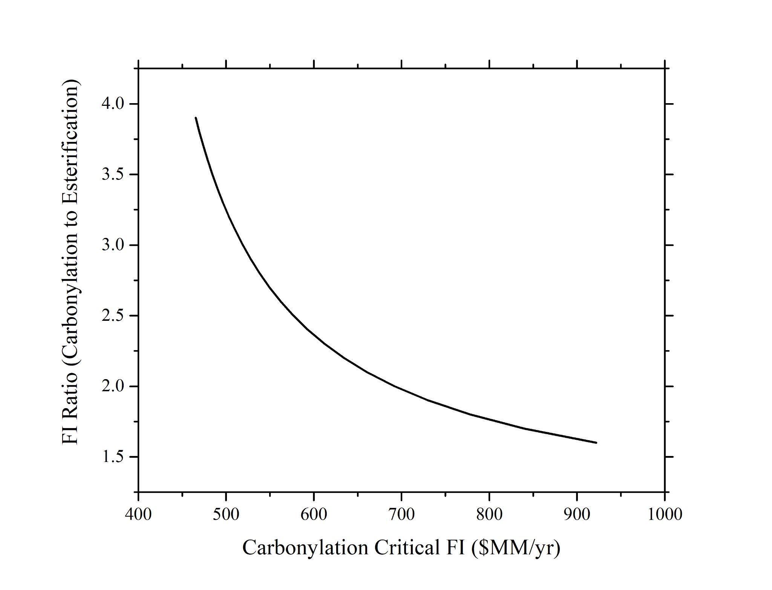

**Figure 1.** Carbonylation v. Esterification Critical FI Graph

The hyperbola in **Figure 1** tells us where the investment is more feasible from the other investment route. For example, if the FIC is at $850MM/yr with a ratio of 3.5, it would suggest that it is better to invest in the esterification route. In other words, if the FIC is at the lower left of the hyperbola, investing in the carbonylation route is more feasible. Moreover, the vertical asymptote of the hyperbola tells the engineer important information, where the FIE is zero. What this suggests is that the engineer can invest in both routes, but this is never true in the real world.

This information can aid the engineers to decide which route to invest in. From a rough estimate of the carbonylation fixed investment (less than $100MM/yr), with a rough FI ratio of 0.5 (FIC:FIE), it is very feasible to invest in the carbonylation route. The major reason why the esterification process requires more investment is because of the usage of acetic acid. It corrodes the carbon steel equipment, which requires the utilization of a more expensive material, stainless steel.

*Final Selection*

**Table 1.** Comparison of VGA, COM, and transfer price of two processes.

| **Route** | Carbonylation | Esterification |
| --- | --- | --- |
| **VGA ($MM/yr)** | 25 | 11 |
| **COM ($MM/yr)** | 215 | 285 |
| **Transfer Price @ 25% NROI ($/tonnes)** | 1,454 | 1,903 |

From the preliminary economic analysis from previously, further economic analysis was performed by considering the VGA, COM, and transfer price of MeOAc for each route. **Table 1** provides the summary and comparison of these parameters. From the table, it is clear to note that while the VGA and NPC are lower with a slightly higher COM and higher NROI for esterification process, the transfer price at 25% NROI for esterification is significantly higher than the value for carbonylation. This can be attributed to the large difference in raw material costs as acetic acid is very expensive, as previously discussed. By referring to **Figure 1,** with a fixed investment ratio of approximately 2.5 for the carbonylation vs esterification, the graph shows that an investment of approximately $600 MM would be required to make esterification competitive. These results also were done with an optimized esterification process while the carbonylation route was not optimized. With a much lower transfer price as well as the results of the fixed investment plot, the carbonylation route was further pursued while the esterification route was ruled out.

**Route Optimization**

*Reactor Optimization*

To optimize the carbonylation process, offline reactors were modeled on MATLAB to determine the catalyst to be used in the dehydration reaction. The two options are the ion-exchange resin, and the H-mordenite catalyst. Since the dehydration reaction is exothermic, the rate of both reactions increases as temperature increases. However, the ion-exchange resin degrades at 100 oC, while the H-mordenite catalyst can be used at temperatures up to 400 oC. However, the cost of the former is $4.90/kg, compared to $70.00/kg for the H-mordenite.

Based on the kinetics provided in the MeOAc paper (attached in **Appendix D**), the plot for catalyst mass as a function of temperature for various conversion percentages are provided for both the ion-exchange and mordenite catalyst in **Figure 2** and **3.** From this, it is evident that the mass of the catalyst required in case of the ion-exchange resin is at least 10 times higher than that for the H-mordenite for similar temperature profiles. However, the cost of the latter is at least 10 times higher than the former, which leaves a delicate balance between both reactants. Moreover, the higher bulk density of the ion-exchange catalyst implies higher catalyst and equipment cost. Finally, after obtaining a converged aspen simulation, the values of temperature and pressure were utilized to find the catalyst mass and the reactor volume, and this process was repeatedly carried out until a convergence was obtained.

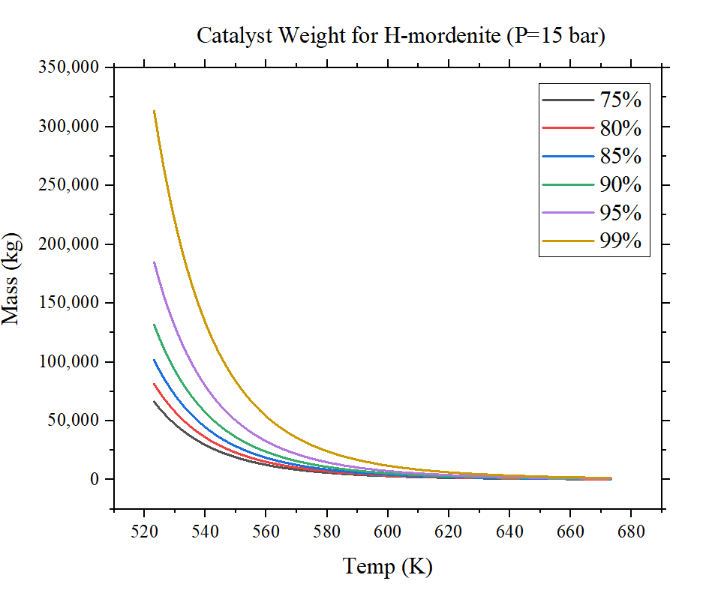

**Figure 2.** Changes in H-mordenite mass with respect to reactor temperature (P = 15 bar).

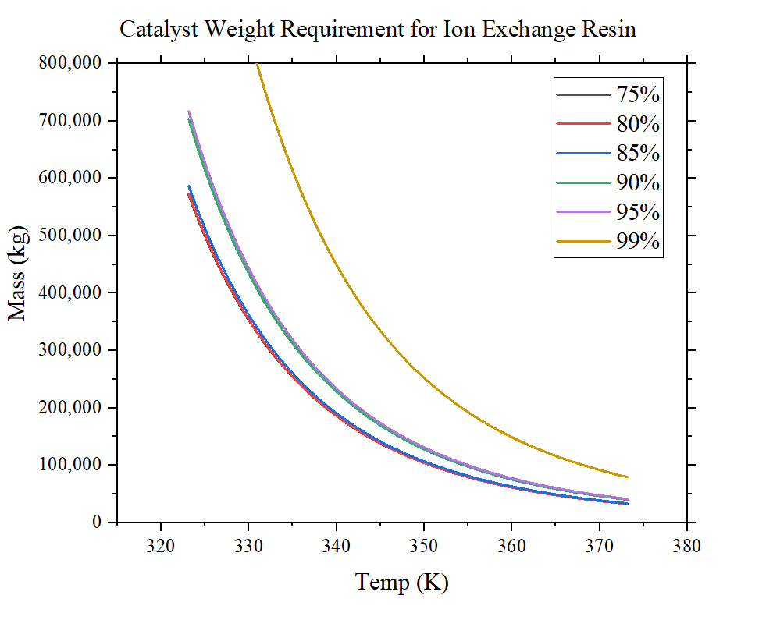

**Figure 3.** Changes in ion-exchange resin mass with respect to reactor temperature (P = 1 bar).

The reactor specifications for the dehydrator and carbonylator can be seen in **Table 2** below. The first step of this optimization involved offline reactor modeling to find kinetic parameters and equilibrium constants. Also, preliminary catalysts masses were found using the bulk densities provided in the main assignment paper. These masses were used to determine the reactor volumes. 1 inch diameter pipes with a 0.5 inch gap between each pipe. With these values and **Eq. 1 - 3**, the reactor areas, number of tubes, and tube length were determined. These values were then inputted into aspen where further simulations optimized the values to what is seen below. For the dehydrator there was a choice between the ion-exchange resin catalyst and the H-mordenite catalyst. The H-mordenite catalyst required was 2,206 kg while the ion-exchange resin catalyst required was 67,995 kg. This led to a much larger reactor size for the resin scenario greatly increasing purchase costs. Also, the total catalyst cost was $154,372 for the mordenite catalyst while the resin catalyst was $333,175. With a cheaper reactor and total catalyst cost, the H-mordenite catalyst was selected. Finally, isothermal reactors were preferred over adiabatic reactors as they provided a better conversion for a similar reactor size.

**Table 2.** Dehydration and Carbonylation Reactor Specifications for H-Mordenite Catalysts.

| **Type of reactor** | Dehydration | Carbonylation |
| --- | --- | --- |
| **Catalyst Mass (kg)** | 2,206 | 78,000 |
| **Number of Tubes** | 1,850 | 15,400 |
| **Tube diameter (m)** | 0.0254 | 0.0254 |
| **Tube length (m)** | 5.64 | 16.38 |
| **Operating Temperature (oC)** | 380 | 209 |
| **Operating Pressure (bar)** | 24 | 15 |

**Eq. 1**

**Eq. 2**

& **Eq. 3**

*Recycle and Separation Structure Optimization*

There are two reactions involved in the carbonylation of MeOAc, which requires separation to optimize the purity of DME feed for the second reaction, and purity of the final product. To achieve this, three distillation columns and a flash tank are utilized. The first distillation column labeled C1, separates DME from methanol and water. The second distillation column further separates the methanol from the water, which is passed through a heat exchanger before being recycled back into the inlet feed. The first distillation column enables separation so that 99% of the inlet fee to the second reactor is DME. The second column maximizes separation of methanol from water, so that minimal methanol is found in the waste stream, which is subsequently treated.

The second recycle and separation structure begins after the carbonylation reactor, where the product feed is fed into a flash tank which separates hydrogen, methane and carbon monoxide from the DME and MeOAc. These gasses are fed into a compressor, and subsequently recycled back into the feed. The remaining contents are passed through a heat exchanger, and subsequently separated via distillation to achieve purity with less than 100 wt% ppm of H2O,DME and MeOH respectively. The separation structure utilized in the process is shown in **Figure 4**.

*Overview of Final BFD*

After optimizing the recycle and separation system, the full flow sheet could be constructed. **Figure 4** shows the optimized flow sheet before heat integration. It begins with fresh methanol being sent into a heater then into the dehydration reactor. The dehydration reactor is running with a coolant temperature of 315oC (DOWTHERM). The subsequent temperature profile shows a peak temperature of 356oC which is below the 400oC catalyst limit. The methanol, dimethyl ether, and water are then sent to the first distillation column to be separated. The 99% DME is distilled and sent further down the process. The bottom of the first column contains the water and methanol from the reaction. This mixture is sent to a second distillation column where the majority of water is separated through the bottom of the column to be treated. The distillate is sent as a recycle combining with the fresh methanol feed before the dehydration reactor. The DME stream is then combined with the carbon monoxide stream and the hydrogen gas stream. This combined stream is then run through the carbonylation reactor to produce methyl acetate. The carbonylation reactor is run with a constant coolant temperature of 190 oC of 10 bar steam. The subsequent temperature profile gives a peak temperature of 223oC. The reason for such a lower temperature for this reactor is because the carbonylation reaction is much more exothermic and could quickly raise the temperature in the reactor. The reactor exit stream is then fed to the flash tank where the majority of the carbon monoxide and methane are distilled while the methyl acetate product, methanol, and small amounts of dimethyl ether are taken from the bottom. The top flash tank stream purges some carbon monoxide, methyl acetate, and methane while the rest is run through a compressor to then be recycled. The bottom flash tank stream is sent to a fired heater to raise pressure and temperature to allow for separation to occur with small amounts of carbon monoxide. The distillate contains waste product while the bottoms contain the 99.99% pure methyl acetate product. **Figure 5** shows the process flow diagram after heat integration was done. The changes compared to the other diagram is the addition of a heat exchanger before the carbonylation reactor. Also the flash tank top stream is run through the heater before the third column before being seperated. Lastly, the condenser from the final distillation column is run through the heat exchanger used for the methanol recycle before being purged. These changes provided a 68% reduction in utility usage.

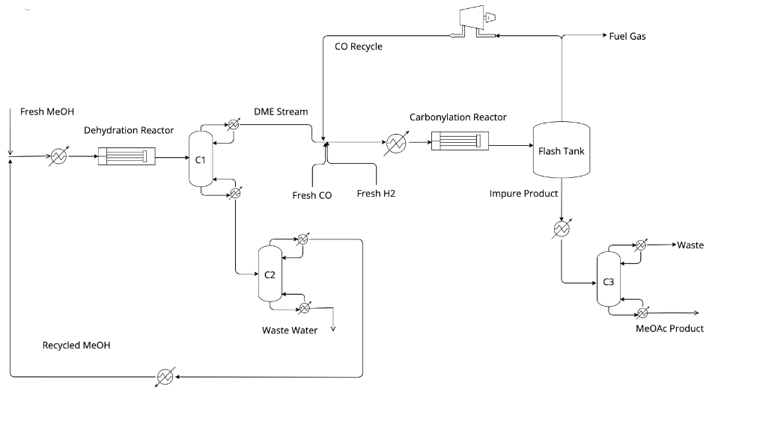

**Figure 4.** Flow Diagram with Optimized Separation Pre Heat Integration.

*Materials of Construction*

The materials of construction utilized in the process were determined on the basis of the chemical used, the temperatures and pressures present in different units. The main chemicals in this process are methanol, dimethyl ether, water, carbon monoxide, methyl acetate, hydrogen and methane. In this process, methanol, dimethyl ether, and water can be stored utilizing carbon steel, as they do not react with the material. Carbon steel piping has an ultimate yield strength of 600 MPa, indicating it can handle the high pressure conditions in the reactor, as the highest pressure reached in this process is 24 bar (in the carbonylation reactor). However, the second part of the process utilizes hydrogen (both as an impurity and as a raw material), which will be pressurized in this case. The major issue which arises with hydrogen is its embrittlement of steel. This could be an issue as the carbonylation reactor operates at 356oC , which is close to the 400oC mark at which the embrittlement process begins. Hence, it is recommended to use austenitic stainless steel to prevent stress failure of the equipment.

*Heat Integration*

In order to reduce utility costs after optimization of the process flow diagram, the process of heat integration was carried out to reduce energy requirements for the process. First, the various streams in this process were divided into hot streams to be cooled, cold streams to be heated, and streams neither heated or cooled. This was followed by calculating the total heat to be added to cold streams, and removed from the hot streams. This led to the formation of the raw composite curve. This was followed up by preparation of the heat cascade table in order to determine the minimum energy requirement for hot and cold streams, followed by formation of the composite curve. Finally, stream matching was carried out at the pinch based on the stream matching feasibility criteria.

Post heat integration, one heat exchanger was added to the process before the carbonylation reactor, while the distillate stream from the flash tank was utilized to heat the fired heater before distillation column C3. Finally, the waste stream from C3 was utilized as a heating fluid for the heater connected to the methanol recycle. This reduced the utility requirement from 60 Gcal/hr to 20 Gcal/hr, resulting in a 68% energy reduction. **Appendix E** details the heat integration carried out for this process.

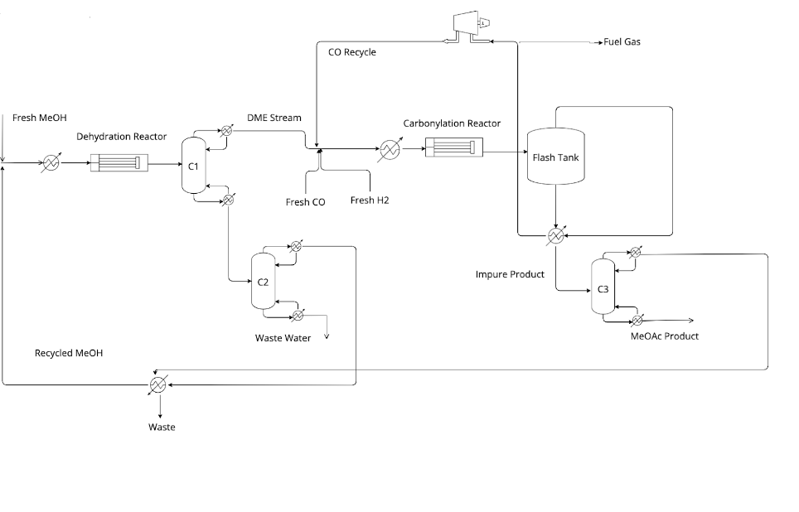

**Figure 5.** Flow Diagram with Optimized Separation Post Heat Integration

**Economic Analysis**

*Back-of-envelope Equipment Sizing*

The back of the envelope (BOE) method was utilized to size all units present in the process to produce methyl acetate (MeOAc). The analysis is done for both pre- and post heat integration (HI). For the pre-HI process, 2 reactors, 3 reboilers, 3 condensers, 1 flash tank, 4 heaters, 1 splitter, and 3 distillation columns were used. Meanwhile, the post-HI process has the same amount and type of equipment used in the pre-HI process, with additional mixer and compressor.

Reactors, reboilers, and condensers were sized by assuming they were heat exchangers. **Appendix F** shows how to find the heat-exchange area by utilizing the heat duty and design flux in the exchanger. Similarly, heaters were also sized by considering the heat duty, but the heat-exchange areas were not required. On top of that, the flash tank is sized by acquiring a diameter and height of the column, as shown in detail in **Appendix G**. Moreover, the sizing method for a distillation column is done with the number of stages and diameter of the column priorly determined. **Table 3** summarizes the heat-exchange area for the equipment that were sized as heat exchangers for pre- and post-HI process.

**Table 3.** Heat-exchange area (ft2) of the equipment for pre- and post-HI process.

| **Equipments** | **Pre-HI** | **Post-HI** |
| --- | --- | --- |
| Reactor 1 | 8,962 | 8,962 |
| Reactor 2 | 216,704 | 216,704 |
| Reboiler 1 | 312.92 | 312.93 |
| Condenser 1 | 3,896.84 | 3,896.86 |
| Reboiler 2 | 1,026.87 | 1,026.87 |
| Condenser 2 | 1,114.24 | 1,114.25 |
| Reboiler 3 | 3,407.06 | 3,531.54 |
| Condenser 3 | 4,670.91 | 4,680.55 |

*Equipment Costing*

To determine the cost related to heat exchangers, it was essential to ascertain the type of heat exchanger required for the process. Thus, the change in inlet temperature, was used as a measure. For < 50oC, the fixed heat heat exchanger was utilized, while for > 50oC, the floating head heat exchanger was utilized. Based on the areas calculated in sizing in **Appendix F**, the bare-module cost of the heat exchangers can be computed as shown in **Appendix H**.

To cost the distillation column, the diameters were first determined from ASPEN. To cost the flash tank, the diameter and length of the tank were found priorly as shown in **Appendix G**. **Appendix I** shows the detailed calculations to cost a distillation column and vertical pressure vessel (flash tank). Furthermore, **Appendix J** and **K** shows how to cost a compressor and fired heaters respectively. **Table 4** listed the comparison in bare-module costs for each equipment for both catalysts.

**Table 4.** Bare-module cost ($MM/yr) of the final process.

| **Equipments** | **Pre-HI** | **Post-HI** |
| --- | --- | --- |
| Reactor 1 | 0.24 | 0.24 |
| Reactor 2 | 10.29 | 10.29 |
| Reboiler 1 | 0.03 | 0.03 |
| Condenser 1 | 0.08 | 0.08 |
| Reboiler 2 | 0.04 | 0.04 |
| Condenser 2 | 0.04 | 0.04 |
| Reboiler 3 | 0.08 | 0.08 |
| Condenser 3 | 0.10 | 0.10 |
| Flash tank | 0.10 | 0.10 |
| Heater 1 | 0.84 | 1.46 |
| Heater 2 | 0.35 | 2.32 |
| Heater 3 | 1.64 | 0.82 |
| Heater 4 | 1.24 | 1.19 |
| Compressor | - | 1.75 |
| Column 1 | 0.86 | 0.86 |
| Column 2 | 0.50 | 0.50 |
| Column 3 | 0.86 | 0.86 |
| Total CBM ($MM/yr) | 17.30 | 20.76 |

*Transfer Price Determination and NPC, NPV and IRR Evaluations*

After computing the cost for each equipment used in the manufacturing process, the total bare-module cost (CBM) is determined in order to solve for the venture guidance appraisal (VGA), which is essentially the fixed investment per year of the process. VGA is determined by considering both total CBM and the cost of replenishing the catalysts. For each reactor used, the amount of catalysts needed were priorly determined. It is assumed that the catalysts have a lifetime of 2 years and by taking that into account, the VGA can be approximately computed. The calculation is performed in a spreadsheet, as shown in **Appendix L**. For pre- and post-HI respectively, the VGA was $53 MM/yr and $63 MM/yr.

From VGA, the cost of manufacture (COM) can be calculated. The calculation is done in another spreadsheet, as shown in **Appendix T**. COM analysis can be broken down into several parts: the variable costs, fixed costs, and finally the cost of manufacture itself. The variable costs alone consist of the ingredient costs, fuel credits, and utilities cost. Table 5 summarizes the variable costs for pre- and post-HI. **Appendix M** shows the detailed calculations to solve for the ingredients, utilities, and fuel credits cost respectively.

**Table 5.** Breakdown of variable costs for pre- and post-HI.

| **Ingredients** | | |
| --- | --- | --- |
| **Type** | **Pre-HI** | **Post-HI** |
| MeOH | 111.13 | 111.13 |
| CO | 20.57 | 20.67 |
| H2 | 3.27 | 3.27 |
| Catalysts | 2.18 | 2.21 |
| **Total** | **137.15** | **137.29** |
| **Utilities** | | |
| **Type** | **Pre-HI** | **Post-HI** |
| Steam | 2.16 | 1.13 |
| Electricity | 0.06 | 0.05 |
| Refrigerant | 1.20 | 0.40 |
| Cooling Water | 0.18 | 0.18 |
| **Total** | **3.60** | **1.76** |
| **Fuel Credits** | | |
| **Type** | **Pre-HI** | **Post-HI** |
| Waste Fuel | 3.12 | 3.12 |

On the other hand, the fixed costs are mainly affected by the number of operators. The operator’s wage is valued at $32/hr. For every two pieces of equipment used in the process, it is estimated that 1 operator will be responsible for handling these two pieces of equipment. For the entire plant, one project manager is needed. Overall, 11 and 10 operators were needed for pre- and post-HI respectively.

In the same COM spreadsheet, once every other cost has been inputted correctly, the transfer price can be computed automatically, by also specifying the desired net return of investment (NROI). The goal is to obtain a 25% NROI.

Another spreadsheet is used as shown in **Appendix N** to determine the net present values (NPV), net present costs (NPC) and internal rate of return (IRR) of the project. These values describe the feasibility of operating the proposed process in a given period of time. Some of the questions that can be answered from this analysis includes when will the plant start making money or the invested money begin to turn into profit, and whether the desired NROI can be achieved within the years, or do better/worse than the desired NROI. **Figure 6** shows the net cash flow (NCF) and NPV of the proposed process for pre- and post-HI, and **Table 6** summarizes the transfer price, NPV, NROI, IRR, and NPC for both pre- and post-HI.

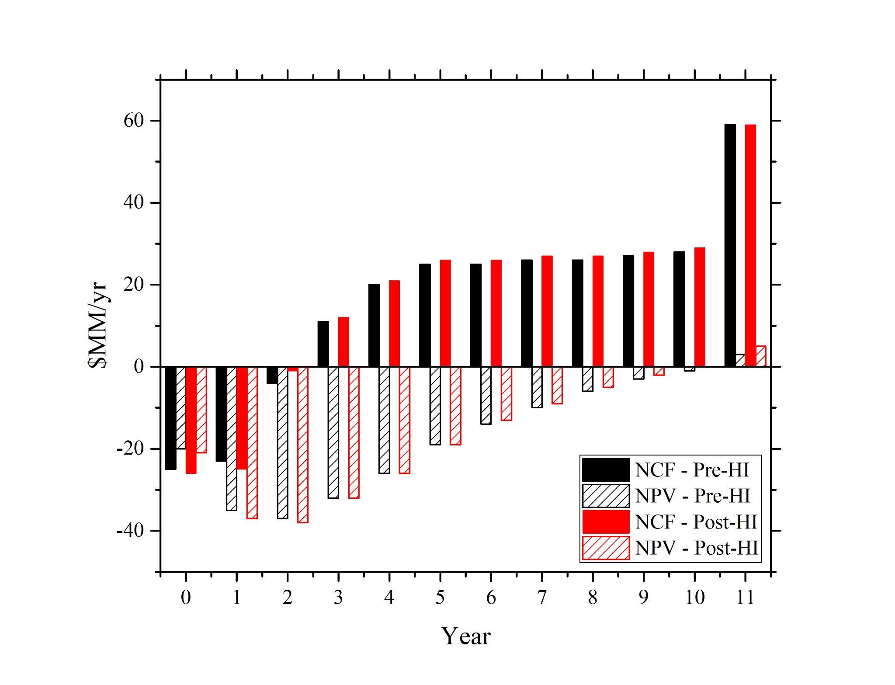

**Figure 6.** NCF and NPV for pre- and post-HI throughout the years of operations.

**Table 6.** Pre- and post-HI’s economics key metrics.

| **Key Metrics** | **Pre-HI** | **Post-HI** |
| --- | --- | --- |
| TP ($/tonnes) | 1,142 | 1,126 |
| NPV ($MM) | 3 | 5 |
| NROI (%) | 25 | 25 |
| IRR (%) | 26.89 | 27.47 |
| NPC ($MM) | 306 | 300 |

**Sensitivity Analysis**

All prior economic analyses were performed by assuming that there will be no variations in parameters considered in the calculations. For example, it was assumed that the cost of methanol is $620/tonne. Sensitivity analysis was performed to see the effect of varying these parameters (production rate, VGA, etc.) on the transfer price of MeOAc, as in the real world, these parameters vary easily. Transfer price is defined as the price associated with the product of the project (MeOAc), which is a small project of a bigger project, which is the manufacture of acetic anhydride. The goal is to have as low of a transfer price as possible, in order to have a lower cost for the overall big project. The analysis was separated into three sets of parameters: 1) production rate, VGA, number of operators, and tax rate, 2) prices of catalysts, MeOH, CO, H2, steam, electricity, cooling water, refrigerant, and operators’ wages, and 3) yield of MeOH, CO, and H2, and usage of steam, electricity, and cooling water. Each parameter was varied within ± 20 % of the original value, and the same values remained for other parameters when one was varied at a time. The goal of this analysis is to determine which parameters greatly affect the transfer price when they are varied, and automatically eliminate those who have insignificant impacts on the price relative to others for further analysis in determining the transfer price of MeOAc. These variations on only post-HI processes are performed in MATLAB (codes are attached in Appendix O) as it is easier to use to handle thousands of random variations. **Figure 7**, **8**, and **9** show the variations of parameter set 1, 2, and 3 respectively.

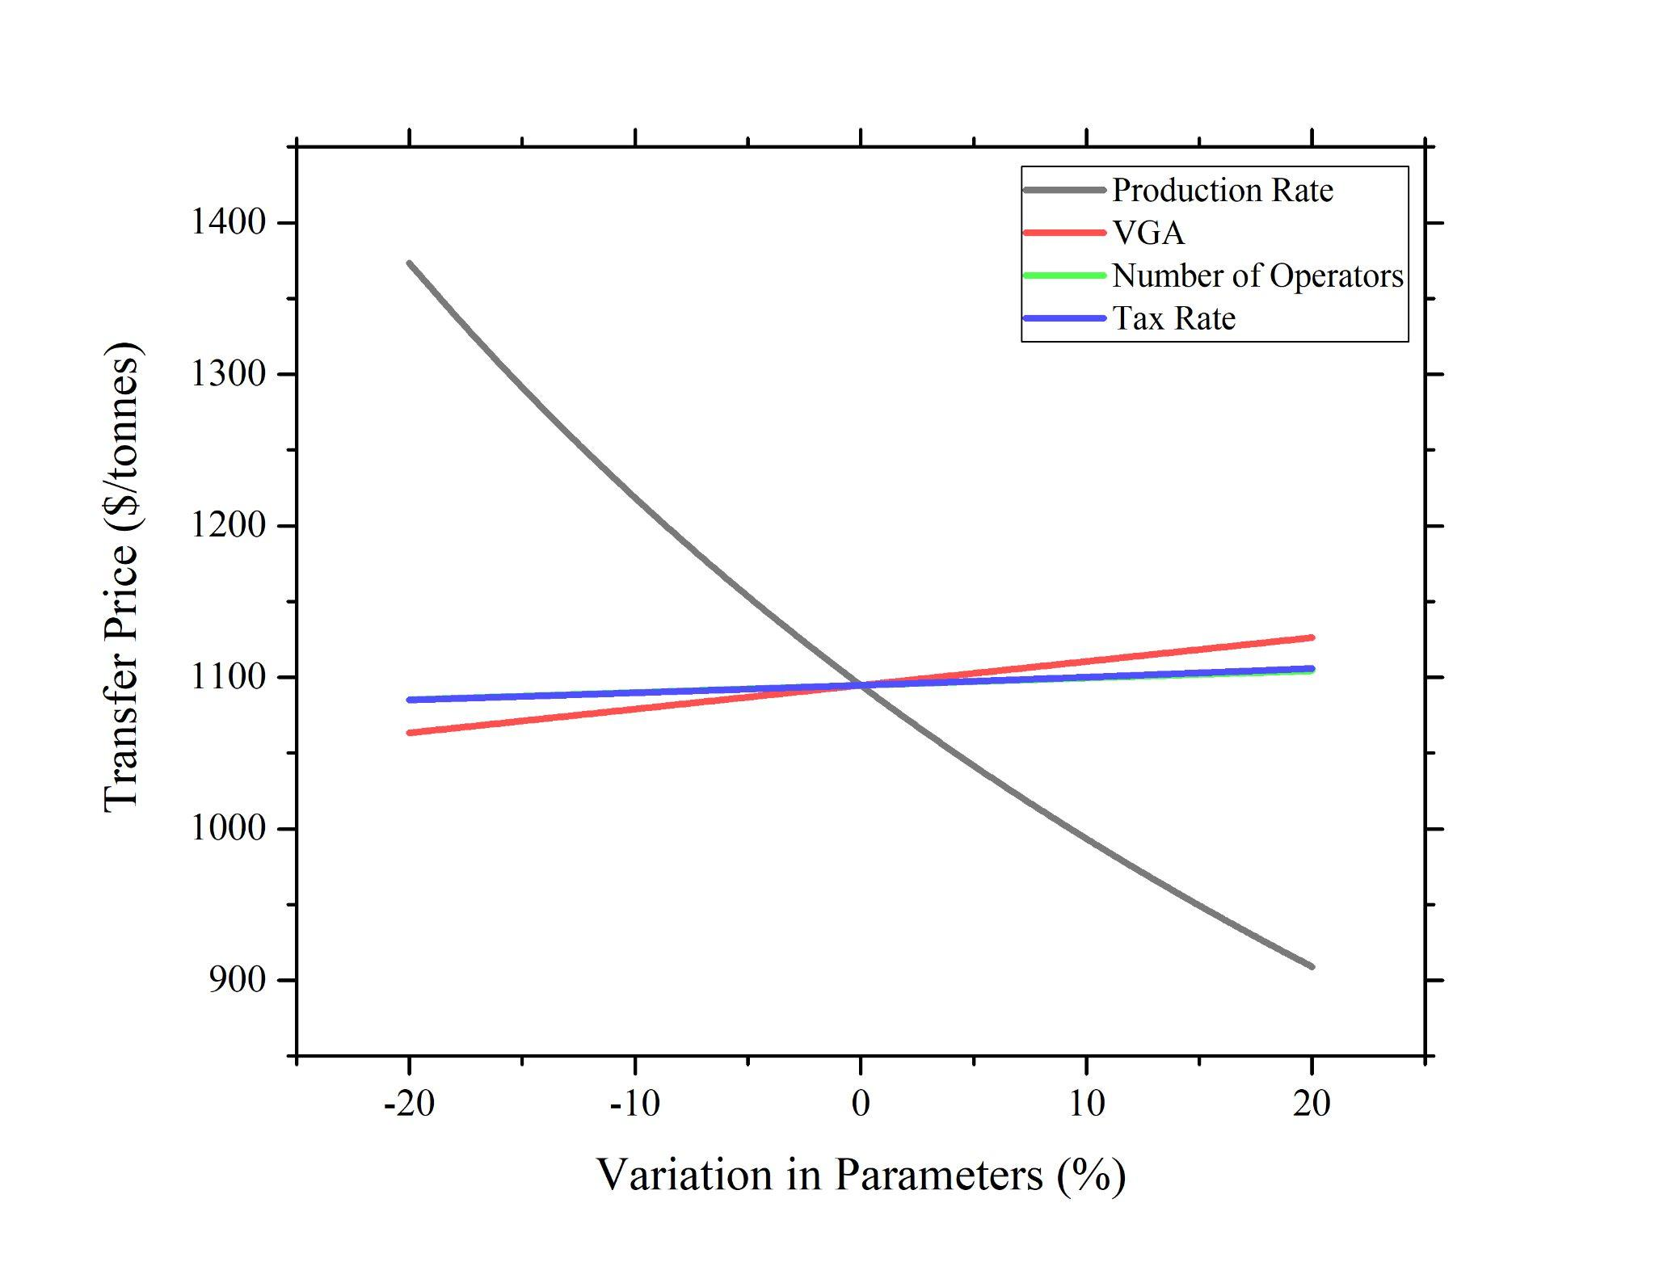

**Figure 7.** Effect of Varying Parameters in Set 1 on Transfer Price of MeOAc.

From **Figure 7**, it could be seen that varying all of the parameters has significant impacts on the transfer price. The price does not remain relatively constant ($1,126/tonnes) within the 20 % variation in parameters. It is interesting to see that the transfer price decreases as the production rate increases. To better understand this change, assume that the “transfer price” is the price of selling MeOAc. By the law of supply and demand, if the demand remains the same, supplying more of the product will lower the market price. This is directly related to the transfer price of MeOAc. Increasing the production of MeOAc will lower the transfer price.

However, the prices change in the same direction as the variations in VGA, number of operators, and the tax rate. This is why this makes conceptual sense. Firstly, increasing the VGA implies that more equipment is needed for the process. Due to that, more utilities are needed (to cool/heat streams, etc…) to operate, thus increasing the variable costs, leading to increase in cost of manufacture. To balance out the increase in cost of operating the equipment, the transfer price should increase too. Secondly, as more operators are hired to operate/monitor the process, more labor costs are needed, which directly affect (increase) the transfer price of MeOAc. Thirdly, the tax rate negatively impacts the NROI. Increasing the tax rate will decrease the actual NROI of the process. This means that the process is now less profitable in relation to the original NROI. Thus, a higher transfer price is needed to compensate for the less profitability of the process.

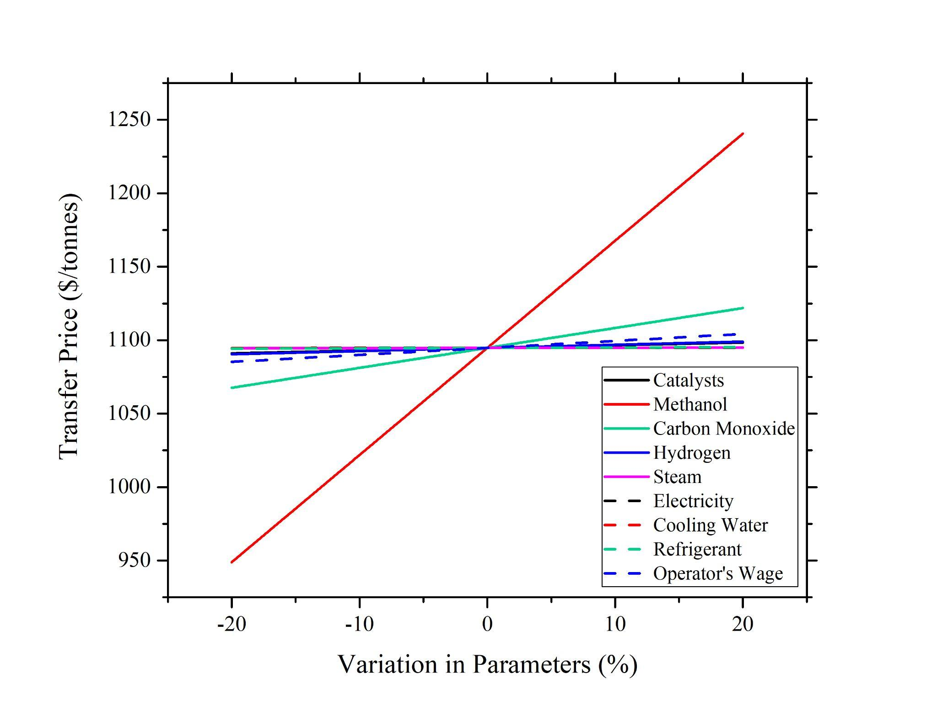

**Figure 8.** Effect of Varying Parameters in Set 2 on Transfer Price of MeOAc.

From **Figure 8**, not all parameters affect the price as much as reflected in **Figure 7**. Varying the price of MeOH, CO, and H2, as well as the operators’ wage, affect the transfer price significantly. Especially MeOH, varying its price by only a little affects the transfer price greatly. This is expected as MeOH is the limiting reactant for the production reaction of MeOAc. Generally, when the ingredient is becoming more expensive, it means that it is less scarce. Thus, if there is a decrease in MeOH supply, it will affect the potential in producing the same amount of MeOAc. In order to compensate for the decline, the transfer price will have to increase too. On top of that, the same can be said for the increase in CO. However, increasing CO’s or H2’s price will not increase the transfer price as greatly as MeOH does, as CO and H2 are not the limiting reactants. Moreover, as previously discussed in the first set of parameters, increasing the operator’s wage directly increases the labor costs, which contributes to the increase in cost of manufacture. To result in the same desired NROI, an increase in transfer price should be expected.

On the other hand, the variations in the cost of steam, electricity, cooling water, and refrigerant have insignificant impact on the transfer price of MeOAc. This is also expected as the utility cost only contributes roughly 2% of the total variable cost. Most of the variable costs come from the total ingredient costs. Other parameters have insignificant effects as the transfer price remains constant around $1040/tonnes. Thus, the insignificant parameters will be ignored for further analysis.

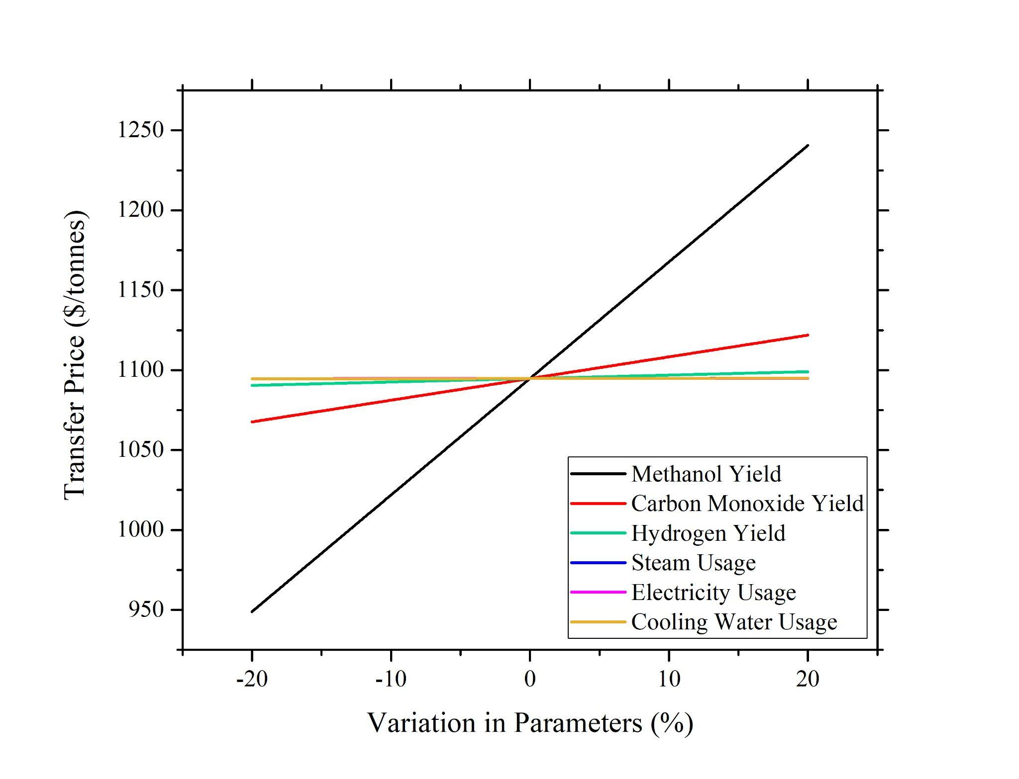

**Figure 9.** Effect of Varying Parameters in Set 3 on Transfer Price of MeOAc.

From **Figure 9**, it could be seen that the variations in the steam, electricity, and cooling water usage do not affect the transfer price that much. Again, this is expected as previously explained, the contributions of utilities usage/cost are very small as opposed to the total variable costs. However, the yield of MeOH, CO, and H2 affect the price significantly. This is also as expected, as previously explained, where these reactants affect the production rate of MeOAc, and MeOH yield affects the transfer price greatly as it is the limiting reactant.

Compiling all parameters that are affecting the transfer price significantly, further analysis was performed involving a Monte Carlo simulation. The simulation shows the probability of having a certain transfer price, by considering all of the significant factors that are affecting the price, as previously discussed. A cumulative probability distribution function of the transfer price is as shown in **Figure 10**.

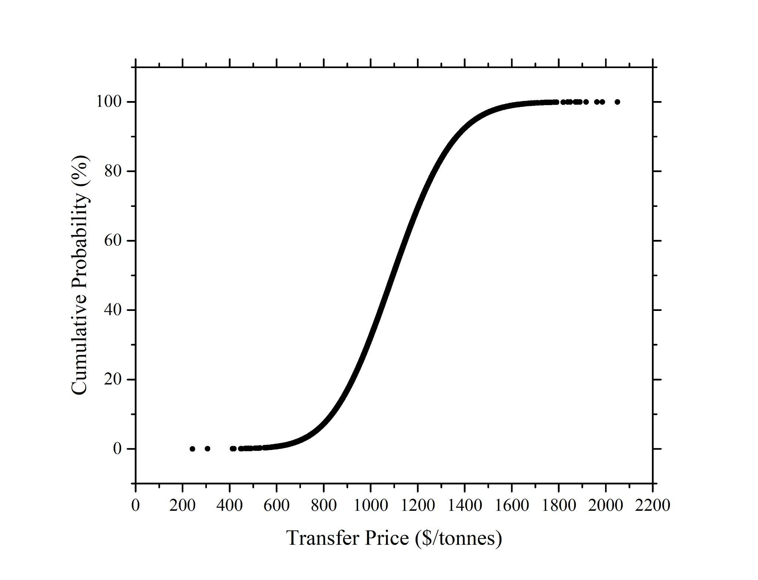

**Figure 10.** Cumulative Probability Distribution Function for Transfer Price of MeOAc.

**Figure 10** shows that the minimum and maximum transfer price that this process can achieve are $200/tonnes and $2,100/tonnes respectively, with a range of approximately $1,900/tonnes. The median price is around $1,100/tonnes. To interpret this graph, the y-axis represents the probability or certainty the particular transfer price can be achieved. To illustrate this example, there is a 10 % chance that the transfer price of MeOAc will be at $850/tonnes. In general, it is important to interpret the range of the transfer price. With a large range of prices, it suggests the big uncertainty in the transfer price estimation. This provides a larger risk to operate the suggested process as the transfer price can vary within a large range.

**Risk Assessment**

*Chemical Safety*

Methanol: Methanol’s Exposure limit is 200 ppm over an 8 hour shift. Highly flammable even at ambient temperatures. Acute Toxicity (oral, dermal, inhalation). PPE required at all times when handling chemicals. When handling methanol, safety glasses with side shields, appropriate gloves, work boots and clothing covering skin. If there are methanol vapors, ventilation equipment is required[5].

Dimethyl Ether: DME’s exposure limit is l000 ppm over an 8 hour shift. Extremely flammable gas that can form explosive mixtures with air. Can cause eye irritation and exposure with liquid DME can cause frostbite. When handling DME, safety glasses with side shields or a face shield is required. Also, work gloves, safety boots, and keep the area well ventilated[4].

Water: Stable substance under normal conditions. Caution must be taken when dealing with phase changes, as well as interaction with organometallics. Use safety glasses with side shields and safety gloves when handling water[9].

Hydrogen: It is a colorless, odorless, cryogenic material. It has no exposure limits, with the main danger being asphyxiation due to displacement of oxygen. However, it is highly combustible and flammable, with high temperatures resulting in rupture of cylinders even before the activation of safety relief valves. While handling hydrogen, ensure that goggles, overalls, along with full face shield, elbow length gloves are worn. Also ensure that safety boots are worn, and avoid ignition sources. Post no smoking/flammable signs near the cylinder[6].

Carbon Monoxide: It is a colorless, flammable, pungent smelling gas. This affects respiratory tracts, alsong with causing eye, skin and embryonal damage. Exposure limits for carbon monoxide is 200 ppm over an 8 hour shift. While handling methane, ensure that goggles, overalls,gloves and safety boots are worn. It should be stored away from sources of heat[7].

Methane: Methane is a colorless, flammable, pungent smelling gas. Inhalation of methane can lead to fatigue and nausea, while high doses could even lead to coma and death. Methane cannot be kept in confined spaces. While handling methane, ensure that goggles, overalls and gloves are worn. Wear thermally resistant gloves while handling liquid methane. Store in dry, ventilated areas which are away from sources of heat. Post no smoking/flammable signs near the cylinder[8].

*Operations Safety*

**Table 7** summarizes the safety in operations of the proposed MeOAc synthesis.

**Table 7.** Tabulated Risk Assessment of MeOAc Synthesis.

| **Risk** | **Probability** | **Consequence** | **Mitigation Step** | **Probability after Mitigation** | **Consequence after Mitigation** |
| --- | --- | --- | --- | --- | --- |
| Pressure Buildup | 15% | Equipment Failure | Pressure Relief Valves, Pressure Sensors | <5% | Reduced Pressure buildup with alarms for emergency |
| Chemical Leak | 10% | Fines, Hazardous Material to Atmosphere | Alarm Systems, Relief Valves/Controls | <5% | More alert workforce who can quickly stop a leak with relief systems |
| Methanol Contamination | 25% | Fines, Harm to surrounding wildlife and drinking water | Water Treatment | <5% | Costs from treatment but reputation saved. |
| MeOAc-Methanol azeotrope | 20% | Lack of pure final product resulting in significant economic loss | Mitigated by utilizing high pressure to ensure the azeotrope is not formed | <5% | Incurs penalty of additional equipment costing but ensures product purity. |
| Effect of purging Methane and CO | 100% | Greenhouse gasses would lead to global warming; CO is also toxic | Mitigated by partial flashing to obtain fuel credit | <15% | Improves the reputation of the company, reduces the effect of global warming. |
| Large Amount of CO is purged | 55% | Significant economic impact on plant operations | Addition of recycle stream | <10% | Incurs slight increase in COM but also leads to acceptable purge of Methane and CO |
| Effect of Feeding Additional Hydrogen Gas | 100% | Hydrogen is highly flammable | Ensure gas is secured in compressed, stainless steel cylinder | <10% | Prevents explosion and damage to plants. |
| Hydrogen Embrittlement[10] | 45% | Stress failure of major equipment | Use austenitic stainless steel for the second half of the plant from the carbonylation reactor | <10% | Increases costs, but reduces threat of temporary/permanent plant closure |

*Carbon Tax*

It has been revealed that the Chief Technology Officer (CTO) has been commissioned by the Department of Energy (DOE) to study the impact of carbon tax on American businesses, and the proposed MeOAc project has been included since carbon tax could potentially impact whether this project should be proceeded with. Both direct and indirect carbon emissions are studied with a taxation of $43/tonne carbon. At the site, it is known that 80% of the heat of combustion can be converted into usable energy. However, the immediate manager is insistent on utilizing 60% efficiency to inflate the impact on carbon tax.

When calculating the direct costs, the yearly flow rate of fuel gas was determined then the $43/tonne metric was used. For the indirect costs, the heat of combustion data was calculated and was converted to the appropriate heat duty. The cost of $5.8/MM BTU was used to calculate the necessary indirect costs. Carbon tax scenario is considered as a risk for the process as the cost of mitigating the carbon can affect the transfer price of MeOAc. A detailed calculation is shown in **Appendix P**.

**Conclusions**

Based on the locus of critical investment curves aided with spreadsheet level balances, it was concluded that carbonylation was a more feasible route for the production of MeOAc compared to esterification. Some of the reasons attributed to this are the high raw material cost of HOAc to produce MeOAc, when compared to similar cost of manufacturing for both plants. Furthermore, it is also recommended to use the H-mordenite catalyst for the dehydration process compared to the ion-exchange resin. Primarily, H-mordenite is already utilized for the carbonylation process, but the higher temperature limit of 400oC compared to 100oC, along with the fact that the dehydration reaction is exothermic implies that higher conversions rates can be achieved with the former. This, along with the pressure dependency implies that a significantly lower amount of catalyst mass is utilized for the H-mordenite catalyst, compared to the ion-exchange resin. After initial optimization, the COM, VGA, transfer price and NPC achieved for the process were $21MM, $53MM, $1,142/tonne and $306MM respectively. Heat integration led to a reduction in utilities at the expense of additional cost of manufacturing, which resulted in the COM, VGA, transfer price and NPC changing to $21MM, $63MM, $1,126/tonne and $300MM respectively. From sensitivity analysis, few parameters were found to have significant impacts on the changes in transfer price of MeOAc when varied. Taking this into considerations for Monte Carlo simulations on the transfer price, it was found that MeOAc can vary from $200/tonnes to $2100/tonnes, which resulted in a large range of prices. Despite the promising economics shown by this process, and its high economic feasibility in production of MeOAc, there are certain risks associated with the production. Primarily, the temperature and pressure conditions of certain vessels are higher than those at an atmospheric level. Additionally, some of the chemicals used in the process are toxic, flammable, and corrosive, and hence, adequate PPE and fire protection systems need to be in place. A detailed safety analysis has been provided for the same, and it is expected that the risks associated with the process are significantly reduced. Hence, it is recommended to proceed with the carbonylation route, but first carry out the process with a pilot scale reactor, followed by thorough screening and safety analysis to start the plant.

**References**

[1] Gates; Johanson. Dehydration of methanol in catalytic fixed bed reactor ... - researchgate. https://www.researchgate.net/publication/349608669_Dehydration_of_Methanol_in_catalytic_fixed_bed_reactor_Dehydration_of_Methanol_in_catalytic_fixed_bed_reactor (accessed May 12, 2022).

[2] Bandiera, J.; Naccache, C. Kinetics of methanol dehydration on delluminated H-mordenite: Model with acid and basic active centres. https://www.sciencedirect.com/science/article/abs/pii/S0166983400832972 (accessed May 12, 2022).

[3] Cheung, P.; Bhan, A.; Sunley, G. J.; Law, D. J.; Iglesia, E. Site requirements and elementary steps in dimethyl ether carbonylation catalyzed by acidic zeolites. https://www.sciencedirect.com/science/article/abs/pii/S002195170600337X (accessed May 12, 2022).

[4] Dimethyl ether - linde US. https://www.lindeus.com/-/media/corporate/praxairus/documents/sds/dimethyl-ether-c2h6o-safety-data-sheet-sds-p4589.pdf?la=en&rev=b0b5f63ac92c4372a7429997926a451c (accessed May 12, 2022).

[5]Methanol Safety Data Sheet - Fisher SCI. https://beta-static.fishersci.com/content/dam/fishersci/en_US/documents/programs/education/regulatory-documents/sds/chemicals/chemicals-p/S25501.pdf (accessed May 12, 2022).

[6] Hydrogen Safety Data Sheet- Airgas. https://www.airgas.com/msds/001026.pdf (accessed May 12, 2022).

[7] Carbon Monoxide Safety Data Sheet - Airgas. https://www.airgas.com/msds/001014.pdf (accessed May 12, 2022).

[8] Methane Safety Data Sheet -Airgas . https://www.airgas.com/msds/001033.pdf (accessed May 12, 2022).

[9] Water Safety Data Sheet - Fisher SCI. https://beta-static.fishersci.com/content/dam/fishersci/en_US/documents/programs/education/regulatory-documents/sds/chemicals/chemicals-p/S25501.pdf (accessed May 12, 2022).

[10] Züttel, A. Materials for hydrogen storage. https://www.sciencedirect.com/science/article/pii/S1369702103009222 (accessed May 12, 2022).

**Appendices**

***Appendix A: Detailed Block Flow Diagram of Esterification Process***

This BFD was based on spreadsheet level balances done initially to compare carbonylation with esterification, and does not represent the final BFD.

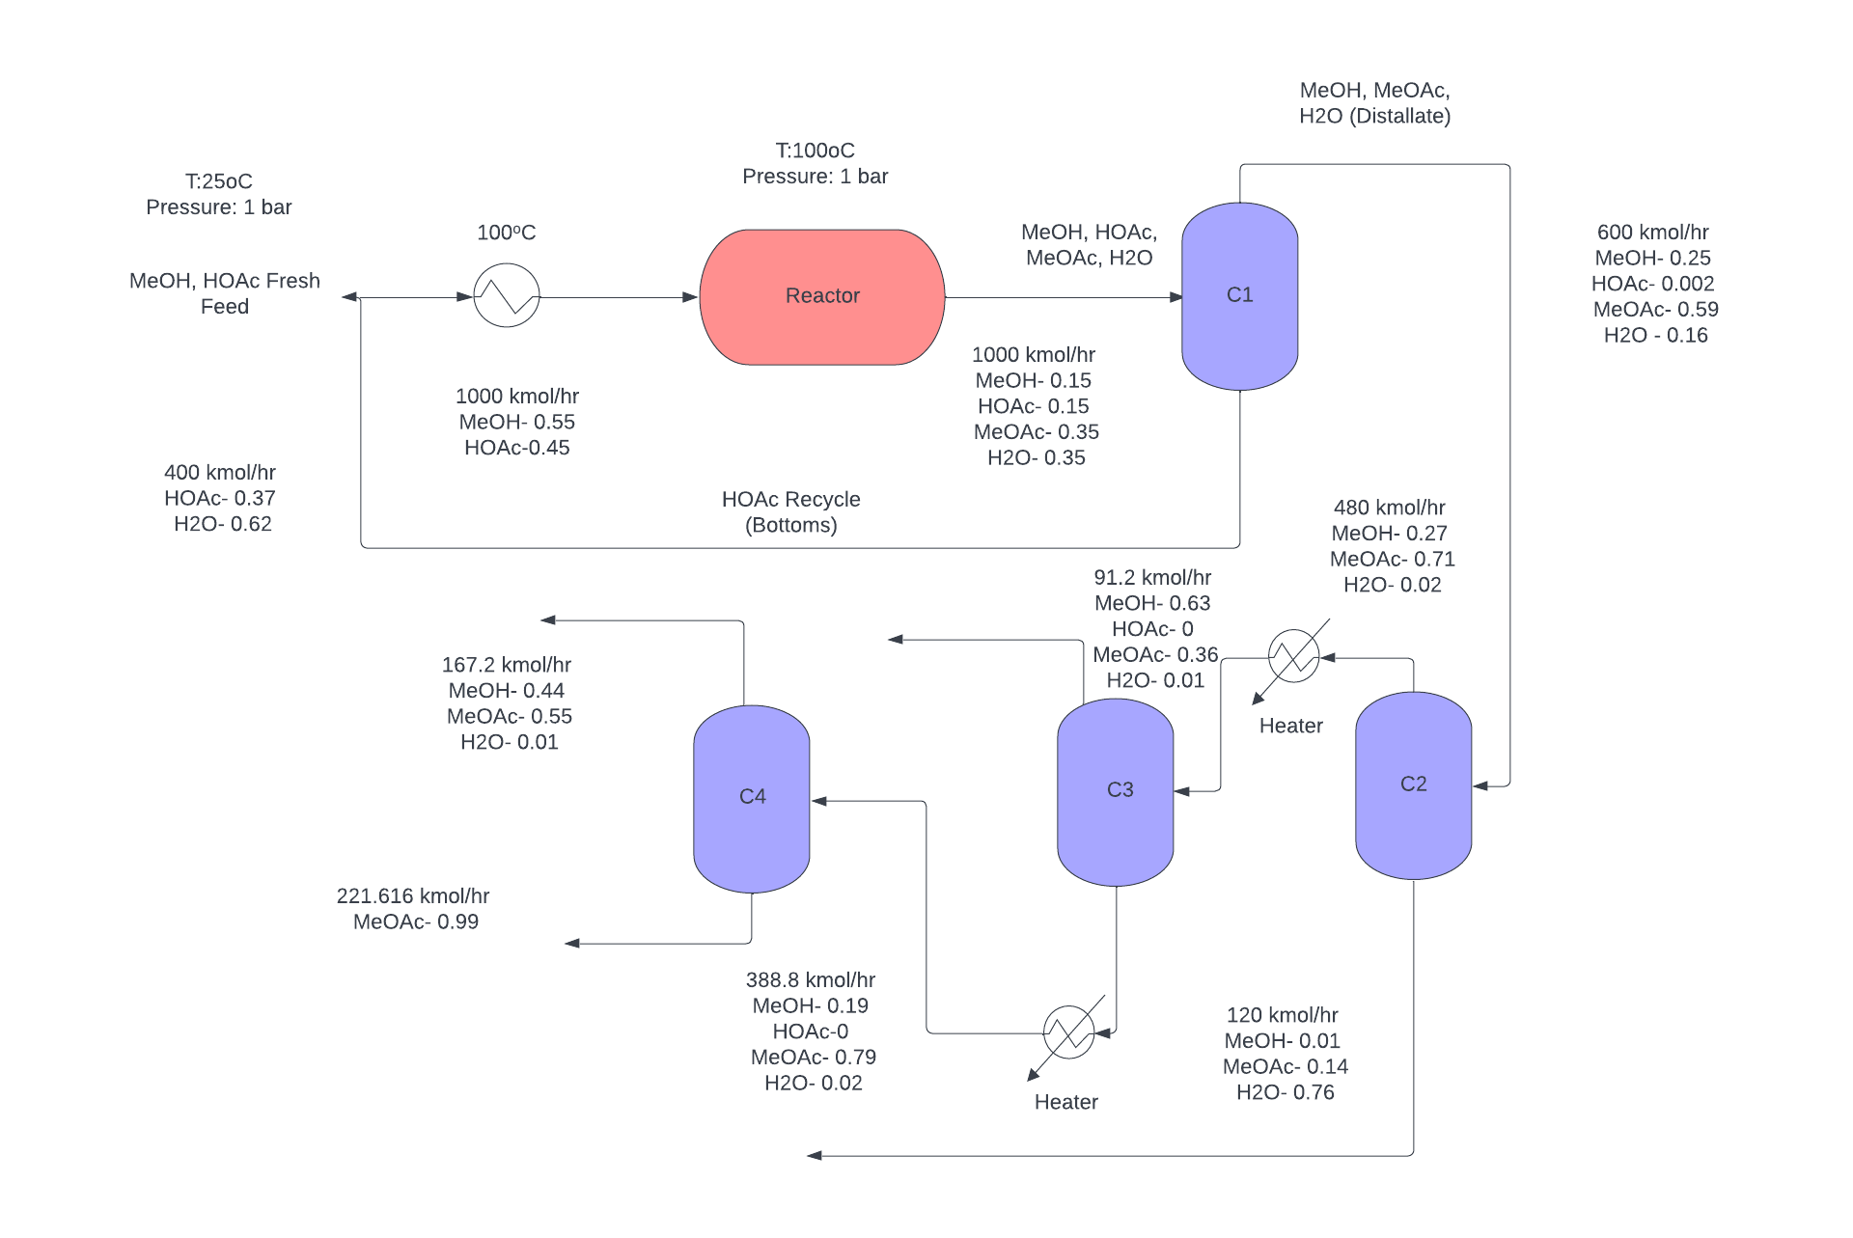  
**Figure A1.** Block flow diagram for idealized esterification process (discontinued due to economic feasibility of carbonylation route).

*Assumptions for Esterification*

The esterification process assumed a 100% yield (i.e. no side reactions) during conversion, and to achieve this, a recycle stream was utilized. A high per pass conversion rate of 100% was also assumed. Since there are two binary azeotropes present, four distillation columns will be used to separate this. The reactor is run at a temperature of 90oC, due to the temperature limitation specified in the prompt, and due to the increase in the rate of reaction as a function of temperature.

**Figure A1** shows the block flow diagram for the esterification process. This diagram was based on spreadsheet balances, with the assumptions for the same given above.A fresh feed of pure methanol and acetic acid, along with the 1st recycle, goes through the dehydration reactor. The temperature of the reactor was chosen at 100oC because this is the optimal temperature accounting for catalyst limitation and kinetics. A heat exchanger is used to heat the fresh feed and recycle to the optimal reactor temperature. After the reactor, there is a stream consisting of MeOAc,MeOH, acetic acid and water. Here, there is an issue in separation of MeOAc-MeOH, which forms a minimum boiling azeotrope at 68% mol of MeOAc. Thus, two distillation columns are required for the separation of this azeotrope.The first distillation column separates most of the acetic acid and water back into the reactor from the bottom, with MeOH,MeOAc and H2O being the products present in the distillate. The second distillation column is utilized to separate water from MeOH and MeOAc. The third and fourth distillation columns are run at elevated pressures in order to break the MeOH-MeOAc binary azeotrope. **Table A1** shows the equipment sizing and **Table A2** shows the equipment costing based on methods given in Seider, Seader, et al. Comparison of VGA, transfer price and NPC is done in **Appendix B.**

**Table A1:** Sizing for various equipment

| **Equipment** | **Area (ft2)** | **Equipment** | **Area (ft2)** |
| --- | --- | --- | --- |
| Reboiler 1 | 2,350 | Condenser 3 | 1,393 |
| Condenser 1 | 5,690 | Reboiler 4 | 2,024 |
| Reboiler 2 | 4,294 | Condenser 4 | 1,409 |
| Condenser 2 | 4,329 | Heat Exchanger | 736 |
| Reboiler 3 | 2,064 |  |  |

**Table A2:** Bare module costs for various equipment

| **Equipment** | **Cost ($)** | **Equipment** | **Cost ($)** |
| --- | --- | --- | --- |
| Reactor | 431,124 | Condenser 1 | 104,829 |
| Distillation Column 1 | 610,398 | Reboiler 2 | 84,757 |
| Distillation Column 2 | 625,769 | Condenser 2 | 85,269 |
| Distillation Column 3 | 616,038 | Reboiler 3 | 56,997 |
| Distillation Column 4 | 633,767 | Condenser 3 | 46,031 |
| Heater 1 | 283,552 | Reboiler 4 | 56,358 |
| Heater 2 | 444,732 | Condenser 4 | 46,296 |
| Reboiler 1 | 56,684 | Heat Exchanger | 32,731 |

***Appendix B: Initial Block Flow Diagram for Carbonylation Process***This BFD was based on spreadsheet level balances done initially to compare carbonylation with esterification, and does not represent the final BFD.

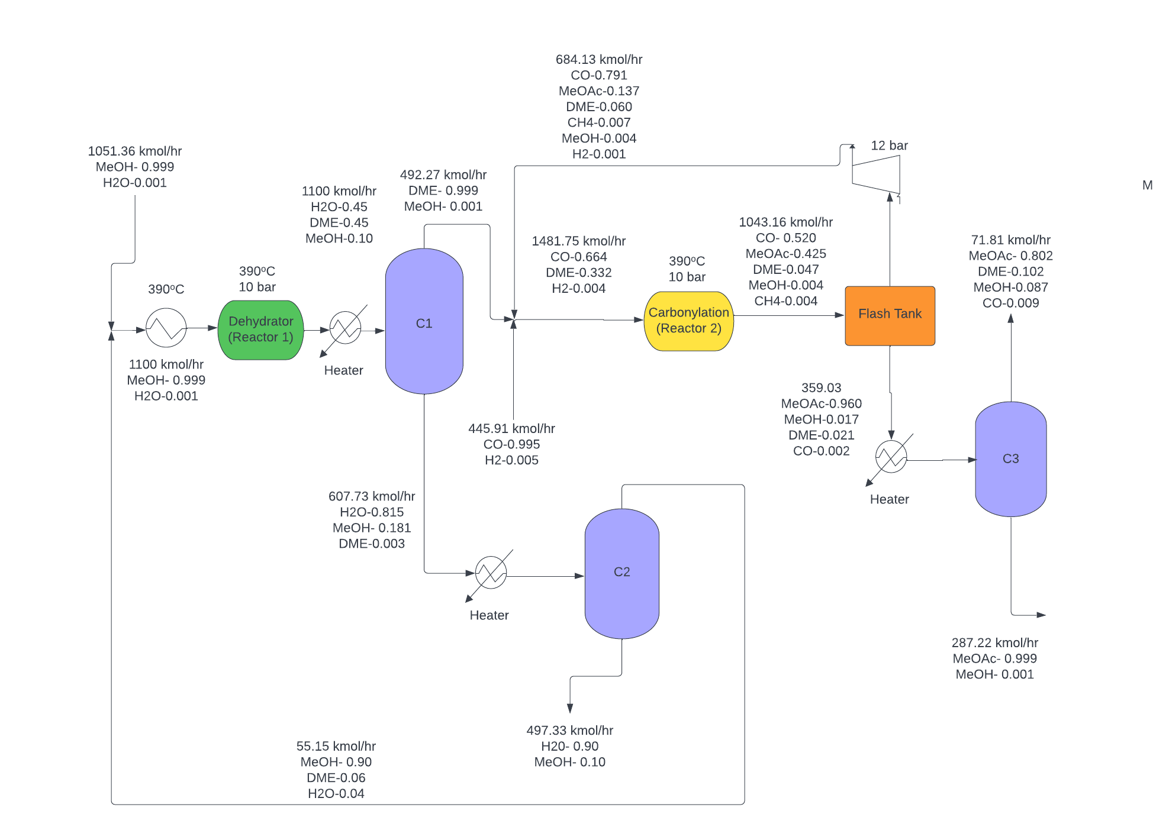

**Figure B1.** Carbonylation Process Flow Diagram H-Mordenite Catalyst

*Assumptions for Carbonylation*

The assumptions made for the carbonylation process were that the initial dehydration of methanol would achieve a 90% per pass conversion. Furthermore, the side reaction was also analyzed in the carbonylation step, with both the main and side reaction achieving a per pass conversion of 90%. The separation structure for the distillation consisted of two fired heaters to increase pressure to aid separation. There are two distillation columns present, to separate the MeOH-DME-H2O ternary. The temperature and pressure conditions for the separation structure were optimized using the ASPEN software. The separation structure for the carbonylation step consisted of a flash tank to separate the CO, H2 and CH4, and another distillation column to recover the MeOAc produced.

**Figure B1** shows the block flow diagram for the carbonylation process, idealized by spreadsheet level balances, and assumptions shown above. The diagram begins with a fresh feed of 99.9 % methanol with water as the impurity. The feed, and the 1st recycle, goes through the dehydration reactor. The product stream is passed through the distillation column where the DME was distilled with 99% purity. The bottoms was separated via another distillation column. The DME mixture was combined with a fresh feed of 99.5% carbon monoxide to the carbonylation reactor. The reactor outlet contained the methyl acetate product as well as carbon monoxide and small amounts of DME, methane, and methanol. Due to the very low boiling point of carbon monoxide, a flash tank was used which removed the gaseous species present. This steam was also compressed to ~ 12 bar to match the feed pressure given. The remaining liquid from the bottom of the flash tank contained the methyl acetate product as well as small amounts of methanol, DME, and carbon monoxide. This stream was then fed to a final distillation column where a 99.9% purity of methyl acetate left the bottom while the remaining DME, methanol, and CO was distilled and purged. The purge is also within the required ppm limits. **Table B1** shows equipment sizing and **Table B2** shows the equipment costing based on methods given in Seider, Seader, et al.

**Table B1**: Equipment sizing

| **Equipment** | **Area (ft2)** |
| --- | --- |
| Heat Exchanger 1 | 1,555 |
| Reboiler 1 | 3,899 |
| Condenser 1 | 4,648 |
| Reboiler 2 | 646 |
| Condenser 2 | 581 |
| Reboiler 3 | 1,217 |
| Condenser 3 | 736 |

**Table B2:** Bare module costs for various equipment

| **Equipment** | **Cost ($)** | **Equipment** | **Cost ($)** |
| --- | --- | --- | --- |
| Reactor | 431,124 | Condenser 1 | 104,829 |
| Distillation Column 1 | 610,398 | Reboiler 2 | 84,757 |
| Distillation Column 2 | 625,769 | Condenser 2 | 85,269 |
| Distillation Column 3 | 616,038 | Reboiler 3 | 56,997 |
| Distillation Column 4 | 633,767 | Condenser 3 | 46,031 |
| Heater 1 | 283,552 | Reboiler 4 | 56,358 |
| Heater 2 | 444,732 | Condenser 4 | 46,296 |
| Reboiler 1 | 56,684 | Heat Exchanger | 32,731 |

**Table B3.** Comparison of VGA, COM, NPC, NROI, and transfer price of two processes.

| **Route** | Carbonylation | Esterification |
| --- | --- | --- |
| **VGA ($MM/yr)** | 25 | 11 |
| **COM ($MM/yr)** | 215 | 285 |
| **Transfer Price @ 25% NROI ($/tonnes)** | **1,454** | **1,903** |
| **Actual NROI (%)** | 32 | 126 |
| **NPC ($MM/yr)** | 330 | 380 |

From the NROI, NPC, transfer price, and locus of critical investment curve, it is clear that carbonylation is a more viable option for the synthesis of MeOAc than the esterification process. Primarily, due to the high price of acetic acid, the fixed investment at which esterification can compete with carbonylation is $500 million. Furthermore, side reactions were assumed for the carbonylation process, whereas no side reactions were assumed for esterification. This was to compare the ‘best case’ scenario for esterification with a non-optimal case for carbonylation. Thus, the carbonylation process could be optimized further to give better estimates for fixed investment costs, and consequently NROI, whereas the esterification process would become worse once the competing reaction is modeled. Moreover, the transfer price of MeOAc sales with the esterification method is higher by $1000 than that for carbonylation, further indicating the deviation between the two. Finally, the recycle structure for the dehydration step in carbonylation was not ideally optimized, which increases chances of improving this further in order to reduce variable costs.

***Appendix C. Calculating the NROI***

**Eq. C1** is used to find the NROI. **Eq. C2 - C6** have to be computed first in order to solve for **Eq. C1**.

**Eq. C1**

**Eq. C2**

**Eq. C3**

**Eq. C4**

**Eq. C5**

**Eq. C6**

**Table C1** summarizes the notations used in all equations to solve for NROI.

**Table C1.** Notation used in NROI determination

| **Notation** | **Definition** | **Values/Unit** |
| --- | --- | --- |
| NROI | Net return on investment | % |
| t | Fractional tax rate | 0.25 |
| R | Revenue | $ |
| COS | Sales cost | $ |
| COM | Manufacturing cost | $ |
| FI | Fixed investment | $ |
| WC | Working capital | $ |
| VC | Variable cost | $ |
| FC | Fixed cost | $ |
| LC | Labor cost | $ |
| n | Operators/shift | - |

***Appendix D: Kinetics of MeOAc Production***

*Kinetics for esterification:*

**Eq. D1**

**Eq. D2**

*Kinetics for the ion-exchange resin (carbonylation):*

**Eq. D3**

**Eq. D4**

**Eq. D5**

*Kinetics for the H-mordenite catalyst (carbonylation):*

**Eq. D6**

**Eq. D7**

**Eq. D8**

**Eq. D8**

***Appendix E: Calculations for Energy/Heat Integration***

Step 5 of the Douglas method deals with heat integration (HI). The first step in this process is to classify streams as heating streams, cooling streams, and the streams which are neither heated or cooled. **Table E1** and **E2** detail the heated streams which would be cooled, and the cold streams which would be heated.

**Table E1.** Detailing Cold Streams from PFD

| **Cold Stream** | **Tlow (oC)** | **Thot (oC)** | **New Label** |
| --- | --- | --- | --- |
| Stream Present in Methanol recycle | 95.35 | 195.00 | C1 |
| Flash Tank Bottom to heater stream | 14.00 | 300.00 | C2 |
| To Reboiler@B13_TO_S15 | 179.89 | 180.39 | C3 |
| To Reboiler@B7_TO_S6 | 120.01 | 127.85 | C4 |
| To Reboiler@B6_TO_S5 | 137.80 | 139.89 | C5 |
| B10_heat | -22.06 | 223.00 | C6 |

**Table E2.** Detailing Hot Streams from PFD

| **Cold Stream** | **Thot (oC)** | **Tcold (oC)** | **New Label** |
| --- | --- | --- | --- |
| To Condenser@B7_TO_S7 | 97.03 | 95.35 | H1 |
| To Condenser@B13_TO_S16 | 167.90 | 4.82 | H2 |
| To Condenser@B6_TO_S9 | 42.77 | 32.10 | H3 |
| B11_heat | 223.00 | 14.00 | H4 |
| B5_heat | 356.00 | 355.50 | H5 |

After this, the design of a heat exchanger network and maximum energy recovery were carried out. The first step in this process was to calculate the total heat to be added to the cold streams, and total heat to be removed from the hot streams. This was done by utilizing **Eq. E1**.

**Eq. E1**

In order to determine the mCp values for the hot and cold streams, the enthalpy of the streams are required. These were obtained from Aspen, along with the inlet and outlet temperatures. Consequently, the mCp values were calculated by **Eq. E2**.

**Eq. E2**

Hence, the mCp values for the streams are given below in **Table E3**.

**Table E3.** mCp values for Hot and Cold Streams

| **Stream** | **Ts (oC)** | **Tt (oC)** | **Enthalpy Flow (kW)** | **mCp (kJ/K)** |
| --- | --- | --- | --- | --- |
| C1 | 95.35 | 195.00 | 1253.56 | 12.58 |
| C2 | 14.00 | 300.00 | 6141.33 | 27.47 |
| C3 | 179.89 | 180.39 | 9985.10 | 19970.22 |
| C4 | 120.01 | 127.85 | 3009.47 | 383.80 |
| C5 | 137.80 | 139.89 | 917.08 | 438.66 |
| C6 | -22.06 | 223.00 | 6687.54 | 27.28 |
| H1 | 97.03 | 95.35 | 3265.51 | 1947.86 |
| H2 | 167.90 | 4.82 | 13685.78 | 83.92 |
| H3 | 42.77 | 32.10 | 11420.50 | 1070.41 |
| H4 | 223.00 | 14.00 | 5800.44 | 21.75 |
| H5 | 356.00 | 355.50 | 9296.15 | 18592.30 |

Based on the mCp values, along with the Tin and the Tout, the initial hot and cold stream tables can be determined. From these, the total heat needed to be added and removed are calculated and as summarized in **Table E2** and **E3**.

**Table E2**: Hot Streams heat removal

| **Temperature Interval (oC)** | **Streams** | **ΣQ[kW]** |
| --- | --- | --- |
| 59.77 | - | 0.00 |
| 90.00 | H3 | 1137.24 |
| 115.29 | H3, H4 | 2759.25 |
| 151.85 | H4 | 3727.87 |
| 151.92 | H4, H2 | 5591.19 |
| 341.00 | H4 | 10601.51 |
| 358.18 | H1 | 10920.69 |

**Table E3**: Cold Streams heat addition

| **Temperature Interval (oC)** | **Streams** | **ΣQ[kW]** |
| --- | --- | --- |
| 47.48 | - | 0.00 |
| 174.99 | C1 | 2984.20 |
| 175.55 | C1, C3 | 5676.49 |
| 183.74 | C1 | 5868.31 |
| 198.33 | C1, C4 | 7773.22 |
| 198.99 | C1, C4, C2 | 7874.30 |
| 210.00 | C1, C2 | 8382.68 |
| 245.05 | C5, C1 | 9346.88 |
| 358.18 | C5 | 9811.20 |

After the summation of the values from hot and cold streams, and taking their difference, it was determined that 15,474 kW of energy needs to be removed from the process in order to meet the first law of thermodynamics requirement. The next step involved plotting the raw hot stream and cold stream curves, which are shown in **Figure E1**.

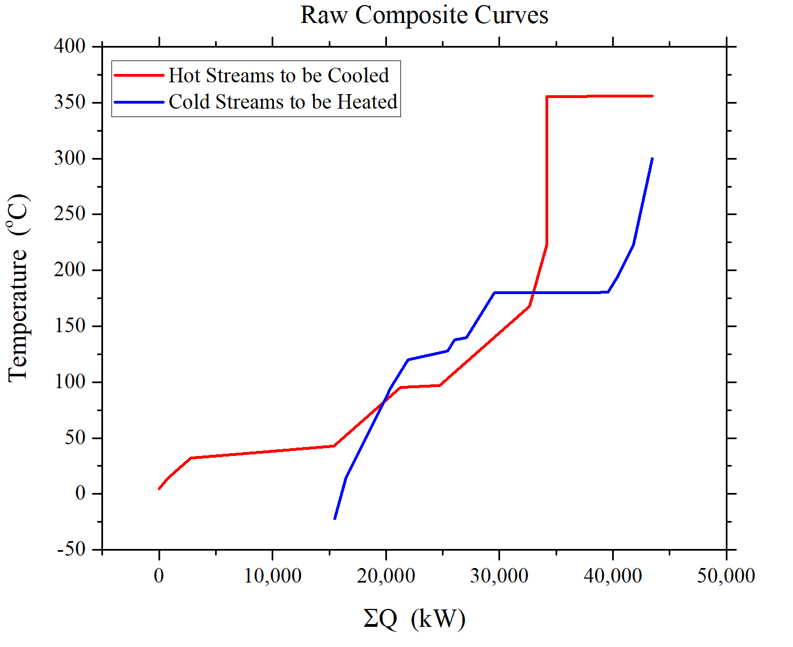

**Figure E1.** Rough Heat Composite Curve

This process clearly shows a violation of the second law of thermodynamics, as the hot streams and cold streams cross over. Hence, the next step is to build a heat cascade table in order to account for this violation. Hence, a ΔTmin of 10oC is assumed, and this value is subtracted from the initial and final value of the hot streams. After this, there is a new interval of temperature ranges for which the heat requirements are calculated. Negative values of heat requirement violate the second law of thermodynamics, which are accounted for by adding heat pertaining to the most negative value, and that value would be the pinch. The pinch temperature was determined to be 155oC. The amount of heat to be added is 4454 kW to the hot stream and 23,000 kW to the cold stream. Consequently, the Minimum Energy Requirement composite curve is shown in **Figure** **E2**. **Table E3** shows the new heat cascade tables.

**Table E3.** Heat Cascade Table

| **Temperature Range** | **Streams** | **ΣQ (kW)** | **Heat To Be Added (kW)** |
| --- | --- | --- | --- |
| 346.00 | H5 | 0.00 | 4454.01 |
| 345.50 | None | 9296.15 | 13750.16 |
| 300.00 | C2 | 9296.15 | 13750.16 |
| 223.00 | C2,C6 | 7642.72 | 12096.72 |
| 213.00 | H4,C2,C6 | 7155.10 | 11609.11 |
| 195.00 | C1,C2,H4,C6 | 6776.95 | 11230.96 |
| 180.40 | C3,C1,C2,C6,H4 | 6286.47 | 10740.48 |
| 179.90 | C1,C2,H4,C6 | -3715.43 | 738.58 |
| 157.91 | C1,C2,C6,H2,H4 | -4454.01 | 0.00 (PINCH) |
| 139.90 | C1,C2,C5,C6,H2,H4 | -3547.63 | 906.38 |
| 137.81 | C1,C2,C6,H4,H2 | -538.16 | 3915.85 |
| 127.86 | C1,C2,C4,C6,H2,H4 | -37.38 | 4416.63 |
| 120.02 | C1,C2,C4,C6,H2,H4 | -2652.23 | 1801.78 |
| 95.35 | C1,C2,C6,H4,H2 | -1410.91 | 3043.09 |
| 87.03 | C2,C6,H2,H4 | -887.31 | 3566.70 |
| 85.35 | C2,C6,H1,H2,H4 | 2483.67 | 6937.67 |
| 32.77 | C2,C6,H2,H4 | 5791.04 | 10245.05 |
| 22.11 | C2,C6,H4,H2,H3 | 17882.71 | 22336.72 |
| 14.00 | C2,C6,H4,H2 | 18392.61 | 22846.61 |
| 4.00 | C6,H4,H2 | 19236.40 | 23690.41 |
| -5.18 | C6,H2 | 19756.43 | 24210.44 |
| -22.07 | C6 | 19295.66 | 23749.66 |

After determination of the MER to be added to the hot and cold utility, the hot and cold stream temperature intervals are calculated again. The updated hot and cold stream values are shown in **Table E4** and **E5**.

**Table E4**: Updated hot streams heat removal

| **Temperature Interval (oC)** | **Streams** | **ΣQ[kW]** |
| --- | --- | --- |
| 59.77 | - | 0.00 |
| 90.00 | H3 | 1137.24 |
| 115.29 | H3, H4 | 2759.25 |
| 151.85 | H4 | 3727.87 |
| 151.92 | H4, H2 | 5591.19 |
| 341.00 | H4 | 10601.51 |
| 358.18 | H1 | 13294.48 |

**Table E5**: Cold Streams heat addition

| **Temperature Interval (oC)** | **Streams** | **ΣQ[kW]** |
| --- | --- | --- |
| 47.48 | - | 3483.28 |
| 174.99 | C1 | 6467.48 |
| 175.55 | C1, C3 | 9159.77 |
| 183.74 | C1 | 9351.59 |
| 198.33 | C1, C4 | 11256.50 |
| 198.99 | C1, C4, C2 | 11357.58 |
| 210.00 | C1, C2 | 11865.95 |
| 245.05 | C5, C1 | 12830.16 |
| 358.18 | C5 | 14403.48 |

**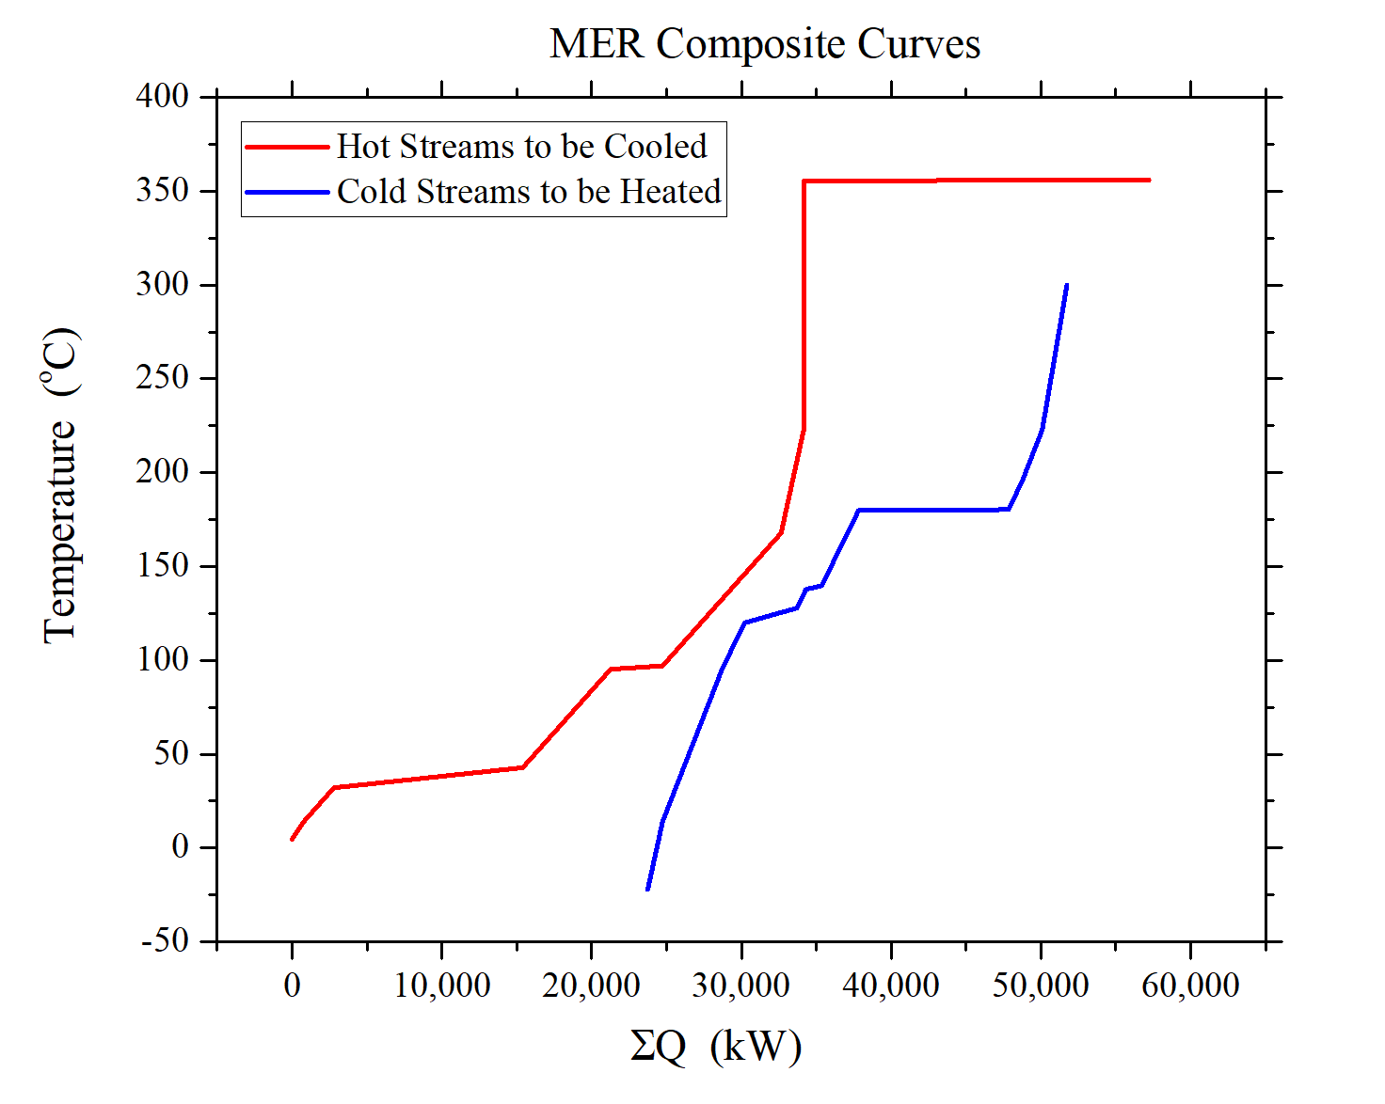  
Figure E2.** MER Composite Curve

After the composite curve, the next step involves matching of hot streams and cold streams at the pinch. The first step is to ensure that ΔTmin  is maintained. For the hot stream side, the stream matching feasibility criteria is (mCp)c > (mCp)h. From this, on the hot side, it was determined that stream H4 (feed into flash), can be cooled by the reboiler from column C2 (stream C4), as this satisfies the criterion. On the cold side, the stream matching feasibility criteria is (mCp)c < (mCp)h. From this, it was determined that stream H4 (feed into flash) will be matched with stream C1. The rest of the streams are managed by cold or hot utilities, as shown in **Figure E3.**

***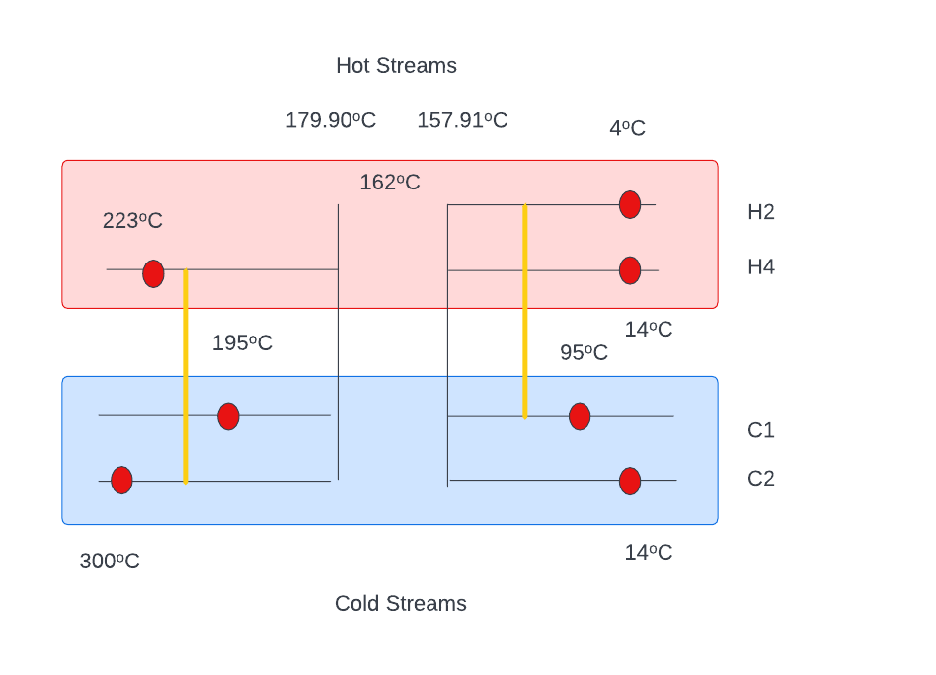*Figure E3:** Stream matching

Finally, **Table E6** and **E7** provides us with the stream matching, and the heat required for the same.

**Table E6**: C2 - H4 cold stream matching

| **Temperature Interval (oC)** | **Heat (kW)** |
| --- | --- |
| Heating | -3829.5 |
| Cooling H4 | 1326.75 |
| Heat to be Removed | -2502.75 |

**Table E7**: C1 - H2 cold stream matching

| **Temperature Interval (oC)** | **Heat (kW)** |
| --- | --- |
| Heating of C1 | -842.86 |
| Cooling of H2 | 13,259.00 |
| Heat to be Removed | 12,416.14 |

***Appendix F: Determination of Heat Exchange Area***

**Table F1.** Various values of heat flux

| **Type of flux** | **Flux value (BTU/hr/ft2)** |
| --- | --- |
| Gas-to-gas | 300 |
| Liquid-to-liquid | 8,000 |
| Phase change | 10,000 |
| Condensing steam | 12,000 |

To find a heat exchange area, the type of flux has to be determined first in order to use the appropriate heat flux value. Assume that it is a gas-to-gas flux with a heat transfer duty of *a* BTU/hr. The heat exchange area is determined as shown in **Eq. F**.

**Eq. F**

***Appendix G: Determining the Length and Diameter of the Flash Tank***

To find the length and diameter of the flash tank, the flow rate into the tank has to be determined first. Let’s use an arbitrary number of 1,043.16 kmol/hr as the inflow rate. This flow rate is converted to m3/hr by considering the molar composition and density of the components in the inflow.

**Table G1.** Molar composition and thermodynamics properties for each component

| **Components, i** | **Molar composition, xi** | **Molar mass, MWi (g/mol)** | **Density, ρi (g/m3)** |
| --- | --- | --- | --- |
| Methanol | 0.0043 | 32.04 | 792,000 |
| Dimethyl ether | 0.0472 | 46.07 | 2,110 |
| Water | 0.0000 | 18.02 | 997,000 |
| Carbon monoxide | 0.5191 | 28.00 | 1,140 |
| Methyl acetate | 0.4247 | 74.08 | 932,000 |
| Hydrogen | 0.0005 | 2.00 | 84 |
| Methane | 0.0043 | 16.00 | 657 |

The flow rate in kmol/hr can be converted to m3/hr by using **Eq. G1**.

**Eq. G1**

From the volumetric flow rate, since flash tanks can be assumed to have 5 minutes residence for half tank (10 minutes for full tank), the total volume of tank can be calculated as **Eq. G2**.

**Eq. G2**

To find the length of the tank, it is assumed to have a cylindrical shape. From the volume formula in **Eq. G3**, the diameter can be found from L/D = 2.5 relationship as priorly assumed. **Table G2** shows the length and diameter computed.

**Eq. G3**

**Table G2.** Diameter and Length for flash tank.

| **Parameter** | **Values (ft)** |
| --- | --- |
| Diameter | 7.23 |
| Length | 18.08 |

***Appendix H: Computing the Purchase Cost of Heat Exchanger***

The purchase cost of a heat exchanger can be calculated by using **Eq. H1**.

**Eq. H1**

To solve **Eq. H1**, **Eq. H2** and **H3** have to be computed first.

**Eq. H2**

**Eq. H3**

**Table H1.** Values of FL

| **Tube length (ft)** | **FL** |
| --- | --- |
| 8 | 1.25 |
| 12 | 1.12 |
| 16 | 1.05 |
| 20 | 1.00 |

It is assumed that the tube length is more than 20 ft, thus FL is 1.00 from **Table H1**. To find FM, since the exchangers are made of carbon steel, the values of a and b are equal to 0, making FM to be 1.00. To solve for CB, **Eq. H4** and **H5** are used for floating- and fixed-head heat exchangers respectively.

**Eq. H4** **Eq. H5**

Finally, to find CBM, **Eq. H6** is used. **Table H2** summarizes the notations used in all equations.

**Eq. H6**

**Table H2.** Notation used in heat exchangers cost determination

| **Notation** | **Definition** | **Unit** |
| --- | --- | --- |
| CP | Purchase cost | $ |
| FP | Pressure factor | - |
| FM | Material factor | - |
| FL | Tube length factor | - |
| CB | Base cost | $ |
| A | Heat exchange area | ft2 |
| P | Pressure | psi |
| a | FM factor | - |
| b | FM factor | - |
| CBM | Bare-module cost | $ |
| FBM | Bare-module factor | - |

***Appendix I: Computing the Purchase Cost of Distillation Column/Vertical Pressure Vessel***

The purchase cost of a distillation column or vertical pressure vessel can be calculated by using **Eq. I1**.

**Eq.I1**

To solve **Eq. I1**, **Eq. I2 - I7** have to be computed first.

**Eq. I2**

**Eq. I3**

**Eq. I4**

**Eq. I5**

**Eq. I6**

**Eq. I7**

**Eq. I8**

Finally, to find CBM, Eq. G6 is used. **Table I1** summarizes the notations used in all equations.

**Eq. I9**

**Table I1.** Notation used in distillation column/vertical pressure vessel cost determination

| **Notation** | **Definition** | **Unit** |
| --- | --- | --- |
| CP | Purchase cost | $ |
| FM | Material factor | - |
| CV | Empty vessel cost | $ |
| CPL | Platform/ladder cost | $ |
| CT | Tray cost | $ |
| NT | Number of trays | - |
| FNT | Tray number factor | - |
| FTT | Tray type factor | - |
| FTM | Tray material factor | - |
| CBT | Base tray cost | $ |
| Di | Inner diameter | ft |
| L | Length | ft |
| W | Vessel weight | lb |
| ρ | Metal density | lb/ft3 |
| /ts | Shell thickness | ft |
| CBM | Bare-module cost | $ |
| FBM | Bare-module factor | - |

***Appendix J: Computing the Purchase Cost of Compressor***

To size a compressor since it is used in the carbonylation process, **Eq. J1 - J3** represent the equations used to find the base cost CB of a centrifugal, reciprocating, and screw compressor, with a consumed power PC range of 200 ≤ PC ≤ 30,000 Hp, 100 ≤ PC ≤ 20,000 Hp, and 10 ≤ PC ≤ 750 Hp respectively.

**Eq. J1**

**Eq. J2**

**Eq. J3**

With engineering assumptions and appropriate power consumed by the process, the base cost can be calculated in order to find the purchase cost CP, as shown in **Eq. J4**.

**Eq. J4**

The turbine drive factor FD and material type factor FM can be determined as listed in **Table J1** and **J2**. From CP, the bare-module cost CBM can be computed as shown in **Eq. J5**. The bare-module factor of a compressor is 2.15.

**Table J1.** Values of FD for different type of turbine drive

| **Type of drive** | **Values of FD** |
| --- | --- |
| Steam turbine | 1.15 |
| Gas turbine | 1.25 |

**Table J2.** Values of FM for different type of turbine materials

| **Type of materials** | **Values of FM** |
| --- | --- |
| Stainless steel | 2.5 |
| Nickel alloy | 5.0 |

**Eq. J5**

***Appendix K: Computing the Purchase Cost of Fired Heater***

To size the fired heater, **Eq. K1** is used to solve for its base cost for a heat duty Q range of 10 ≤ Q ≤ 500 MM BTU/hr. The purchase cost is computed by using **Eq. K2**.

**Eq. K1**

**Eq. K2**

The pressure factor FP is calculated from **Eq. K3**, with a pressure P range of 500 ≤ P ≤ 3,000 psig.

**Eq. K3**

Again, engineering assumptions have to be made in terms of choosing the materials for fired heaters to be economically feasible and safe to operate. The material factor FM is as listed in Table K1.

**Table K1.** Values of FM for different type of heater materials

| **Type of materials** | **Values of FM** |
| --- | --- |
| Cr-Mo alloy | 1.4 |
| Stainless steel | 1.7 |

Lastly, the bare-module cost can be computed from **Eq. K4** with FBM values of between 1.86 (field-fabricated fired heaters) and 2.19 (shop-fabricated fired heaters).

**Eq. K4**

***Appendix L: Venture Guidance Appraisal Spreadsheet***

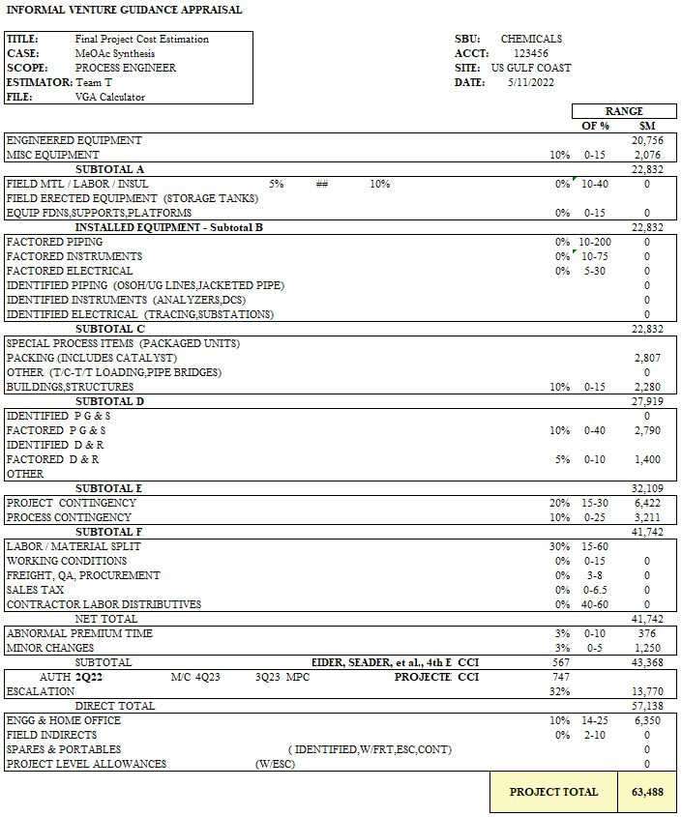

***Appendix M: Variable Costs Breakdown Detailed Calculations***

One of the components in the variable costs is the ingredient cost. The ingredient costs are calculated in the cost sheets (COM). The ingredients include the MeOH, CO, H2, and the catalysts. The COM sheet uses quantity per unit of production (QPU) basis in the calculation. Thus, each utility has to be based on the total production of MeOAc. Let’s say the production rate of MeOAc is 120 MM kg/yr. QPU for the chemicals and catalysts are as shown below:

*QPU for MeOH/CO/H2*

From here, the chemicals have a QPU’s unit of . For a chemical cost of $b/kg of chemicals, then, the cost per kg of MeOAc would be:

*QPU for Catalysts*

From here, the catalyst have a QPU’s unit of . For a catalyst cost of $c/kg of chemicals, then, the cost per kg of MeOAc would be:

The other component to the variable cost is the utility cost. It also uses the QPU basis in the COM sheet. Let’s assume that the process utilizes 7.14 klb/hr, 102.7 kW, and 0.087 MMGal/hr of utility for steam, electricity, and cooling water respectively, with the same production rate of MeOAc as previously stated. The QPU for each parameter can be determined as follows:

*QPU for Steam*

From here, steam has a QPU’s unit of . The utility cost is $11.45 per 1000 lbs of steam. Then, the cost per kg of MeOAc would be:

Since we are producing 120 MM kg/yr of MeOAc, the total cost associated to steam utility is:

*QPU for Electricity*

From here, steam has a QPU’s unit of . The utility cost is $0.061 per kWh of electricity. Then, the cost per kg of MeOAc would be:

Since we are producing 120 MM kg/yr of MeOAc, the total cost associated to steam utility is:

*QPU for Cooling Water*

From here, steam has a QPU’s unit of . The utility cost is $0.075 per 1000 Gal of cooling water. Then, the cost per kg of MeOAc would be:

Since we are producing 120 MM kg/yr of MeOAc, the total cost associated to steam utility is:

The last component to the variable cost is the fuel credits. Fuel credits took into account the amount of chemicals that were no longer used or flowing out of the entire process. This describes the stream flowing out of the bottom of the second distillation column, the purge stream, and the distillate of the third/last column. The calculations were performed by considering the total flow rates, the heat of combustion of each chemical, and the amount of energy in BTU/yr produced after burning these chemicals (meaning they;re are no longer used). **Table M1** summarizes the information needed to determine the total energy required for fuel credits expense.

**Table M1.** Total Energy Spent to Burn the Waste Fuels

| **Chemicals** | **Flow rate (kmol/hr)** | **Mole Fraction** | **Heat of combustion (kJ/mol)** | **Total energy (BTU/yr)** |
| --- | --- | --- | --- | --- |
| Methyl Acetate | 40.80 | 0.08 | 1672.00 | 517,206,884,081 |
| Methanol | 23.50 | 0.05 | 726.10 | 129,393,664,026 |
| Dimethyl Ether | 0.00 | 0.00 | 2726.30 | 1 |
| Carbon Monoxide | 110.76 | 0.21 | 252.50 | 212,060,815,223 |
| Hydrogen | 2.25 | 0.00 | 286.00 | 4,879,452,880 |
| Water | 338.53 | 0.66 | 0.00 | 0 |
| Methane | 0.00 | 0.00 | 890.70 | 0 |
| **Total** | **515.84** | **1.00** | **-** | **863,540,816,211** |

***Appendix N: Net Present Values Spreadsheet***

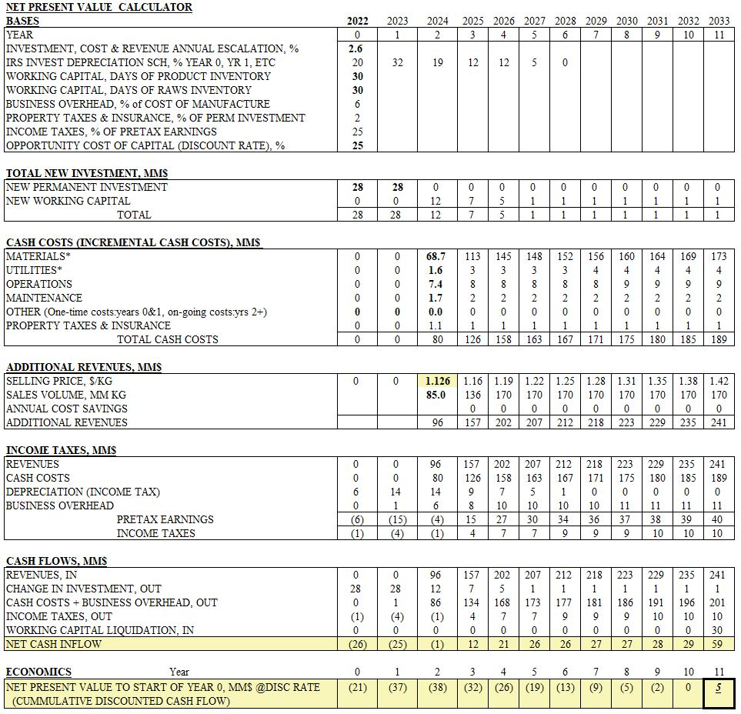

***Appendix O: MATLAB Codes for Sensitivity Analysis***

*Codes to Plot the Effect of Variations in Parameters to the Transfer Price of MeOAc*

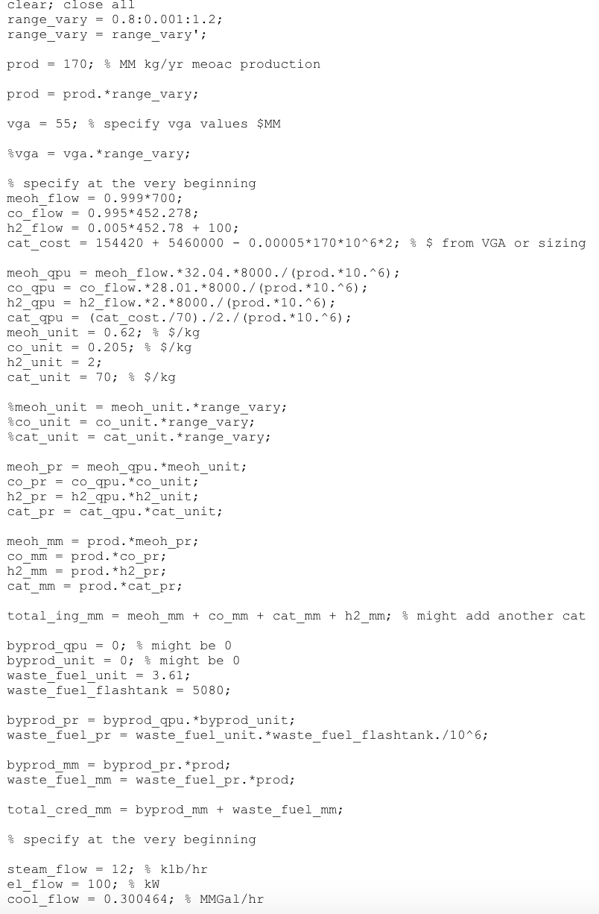

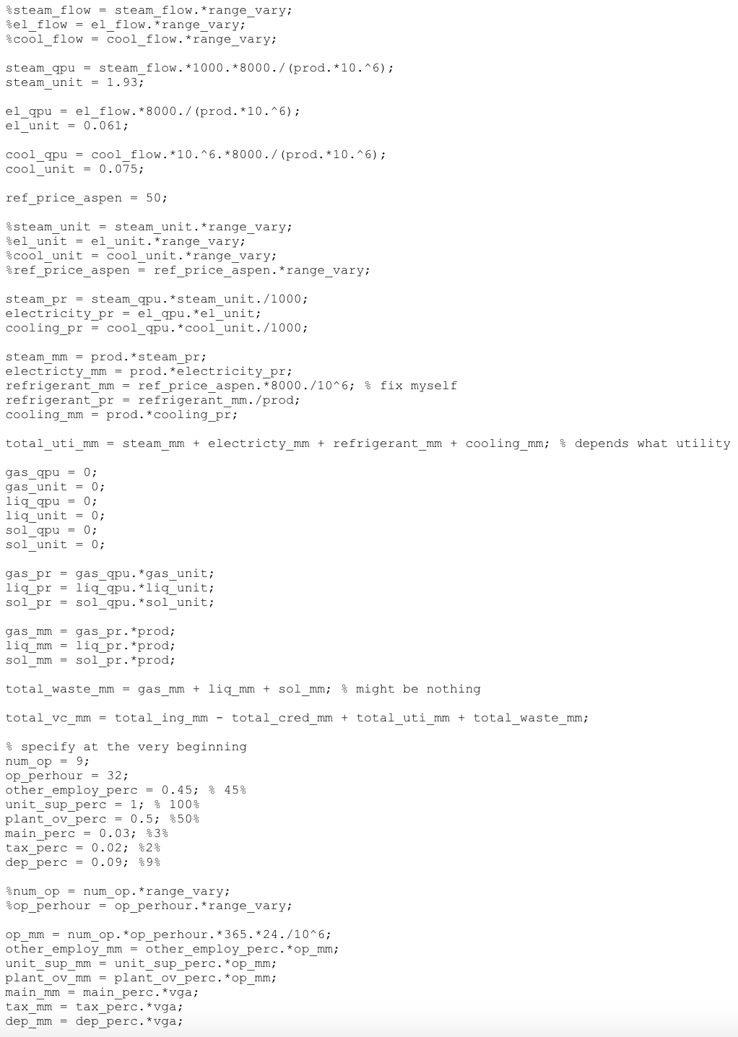

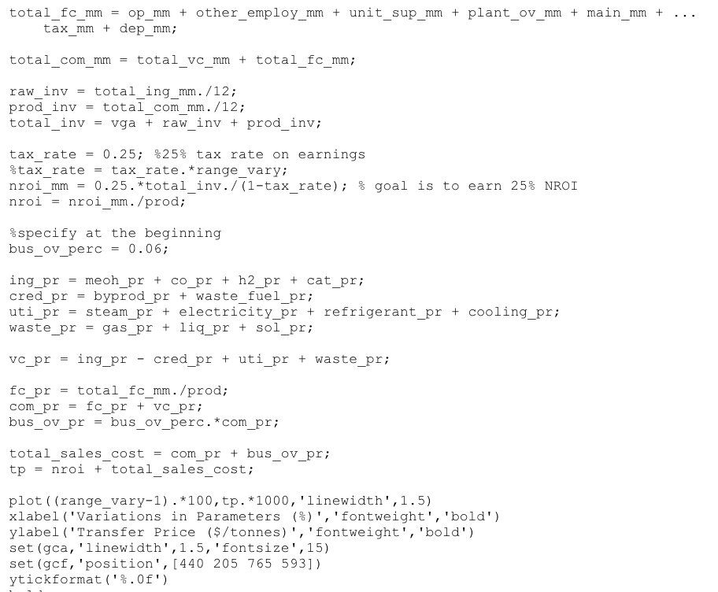

*Codes for Monte Carlo Simulation*

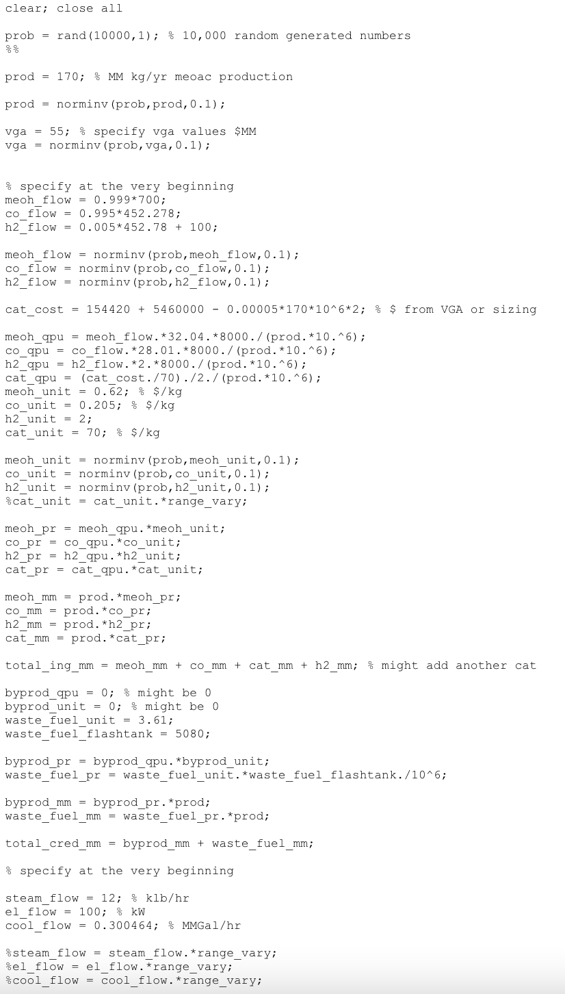

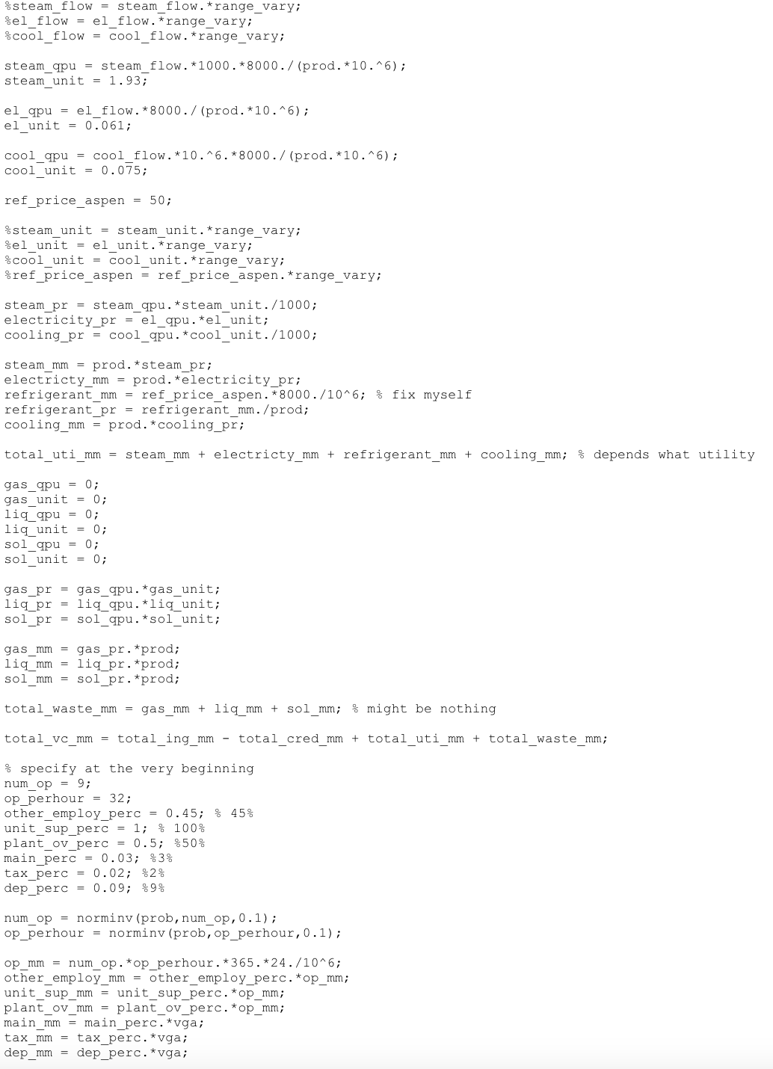

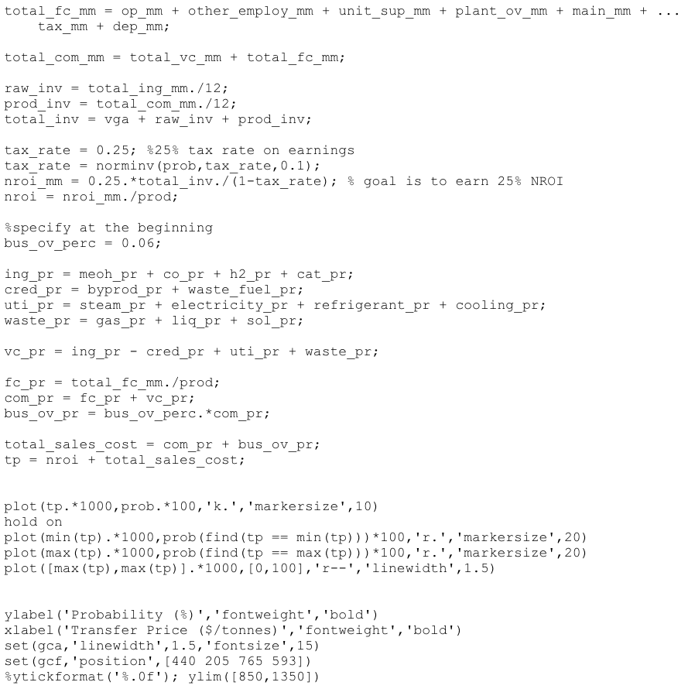

***Appendix P: Carbon Tax Scenario as One of the Risk Assessments***

This is crucial because the impact of carbon tax on the proposed cumene project can potentially impact the decision on whether to proceed with the project or not. Both direct and indirect carbon emissions were studied with a taxation cost of $43/tonne of carbon. **Table P1** summarizes the indirect and direct costs of the project, for both pre-and post-heat integration.

**Table P1.** Total Costs at 80% and 60% Efficiency

| **Type of Costs** | **Pre-HI** | **Post-HI** |
| --- | --- | --- |
| Direct Costs ($MM/yr) | 4.455 | 4.463 |
| a Indirect Costs ($MM/yr) | 6.272 | 6.261 |
| b Indirect Costs ($MM/yr) | 8.362 | 8.348 |

a Indirect costs 80% efficiency

b Indirect costs 60% efficiency

It could be seen that it is cheaper for the post-heat integration. It shows that the addition of a heat exchanger helps to reduce the emissions of carbon, in turn reducing the costs to mitigate the emissions. These carbon tax scenarios were implemented in the COM sheets, which affects the variable costs of the process.

The choice of efficiency depends on the revenue generated from the sale of cumene. The difference in indirect costs of about $2MM/yr between the two efficiencies are nearly negligible compared to the revenue made (~$200MM). The difference in indirect costs is only less than 1% of the total revenue made. From here, we are assuming the best case scenario condition, where the efficiency to operate the process is 80%, assuming the plant workers are proficient.

Carbon tax is closely related to the fuel credits calculation. **Table P2** again summarizes the required information to determine how much should be spent to mitigate the carbon emission.

**Table P2.** Summary of the compositions of the waste streams.

| **Chemicals** | MeOAc | MeOH | DME | CO | H2 | H2O | CH4 |
| --- | --- | --- | --- | --- | --- | --- | --- |
| **Flow rate (kmol/hr)** | 41 | 24 | 0 | 111 | 2 | 339 | 0 |
| **Mole fractions** | 0 | 0 | 0 | 0 | 0 | 1 | 0 |
| **Heat of combustion (kJ/mol)** | 1,672 | 726 | 2,726 | 253 | 286 | 0 | 891 |
| **Heat per hour (kJ/hr)** | 68,210,537 | 17,064,760 | 0 | 27,967,110 | 643,514 | 0 | 0 |
| **Heat per year (MMBTU/yr)** | 517,207 | 129,394 | 0 | 212,061 | 4,879 | 0 | 0 |

By using the heat of combustion data for each chemical, the heat associated for each chemical produced per hour can be calculated, which can be converted to MMBTU/yr. A sample calculation is as shown below:

For the direct cost of the carbon tax scenario, which solely depends on the waste stream flows, the quantity per unit of production (QPU) is determined as follows:

It was taxed to have a $43/tonne of carbon, in which the direct cost can be calculated as such:

For the indirect cost of the carbon tax scenario, it depends on the heat per year associated with the process. First the QPU can be found as follows, by directly employing the efficiency of the process:

By using the cost $5.8/MMBTU, the indirect cost with a certain efficiency can be calculated as such:

***Appendix Q: Final Stream Table Values***

**Table Q1** provides the material flows in the process

**Table Q1.** Material flows of the MeOAc process.

| **Parameter** | **Value(kmol/hr)** | **xMeOH** | **xDME** | **xH2O** | **xCO** | **xMeOAc** | **xH2** | **xCH4** |
| --- | --- | --- | --- | --- | --- | --- | --- | --- |
| Fresh Methanol Feed | 700 | 0.999 | 0 | 0.001 | 0 | 0 | 0 | 0 |
| Total Mixed Feed | 816 | 0.991 | 0 | 0.009 | 0 | 0 | 0 | 0 |
| Feed out of Reactor to Column C1 | 816 | 0.17 | 0.41 | 0.42 | 0 | 0 | 0 | 0 |
| Distillate 1 | 342 | 0.01 | 0.99 | 0 | 0 | 0 | 0 | 0 |
| Bottoms to Column C2 | 475 | 0.29 | 0 | 0.71 | 0 | 0 | 0 | 0 |
| Waste Water Stream | 349 | 0.01 | 0 | 0.99 | 0 | 0 | 0 | 0 |
| Recycle Feed (Distillate C2) | 126 | 0.95 | 0 | 0.05 | 0 | 0 | 0 | 0 |
| Fresh CO Feed | 453 | 0 | 0 | 0 | 0.995 | 0 | 0.005 | 0 |
| Fresh H2 Feed | 100 | 0 | 0 | 0 | 0 | 0 | 1 | 0 |
| Combined Stream | 1150 | 0.012 | 0.294 | 0 | 0.550 | 0.007 | 0.087 | 0.050 |
| Feed out of Reactor 2 to Flash Tank | 854 | 0.133 | 0.01 | 0 | 0.345 | 0.404 | 0 | 0.117 |
| Flash Tank Distillate | 412 | 0.011 | 0.001 | 0 | 0.711 | 0.035 | 0 | 0.242 |
| Recycle Stream from Flash Tank | 256 | 0 | 0.001 | 0 | 0.735 | 0.032 | 0 | 0.234 |
| Purge Stream from Flash Tank | 155 | 0.001 | 0.001 | 0 | 0.697 | 0.031 | 0 | 0.270 |
| Flash Tank Bottom | 428 | 0.221 | 0.003 | 0 | 0 | 0.776 | 0 | 0 |
| Distillate Column C3(Waste) | 138 | 0.710 | 0.010 | 0 | 0 | 0.280 | 0 | 0 |
| Bottoms Column C3(Product) | 290 | 0.00001 | 0 | 0 | 0 | 0.99999 | 0 | 0 |

***Appendix R: Temperature, Pressure Conditions for final case***

**Table R1.** Parameters for all equipment except distillation columns

| **Parameter** | **Temperature(oC)** | **Pressure (bar)** |
| --- | --- | --- |
| Heater 1 | 195 | 10 |
| Reactor 1 | 356 (Highest Temp from profile) | 24 |
| Heater 2 | 195 | 10 |
| Mixer | - | 5 |
| Heater 3 | 195 | 5 |
| Reactor 2 | 223 (Highest Temp from profile) | 15 |
| Flash Tank | 14 | 4 |
| Heater 3 | 300 | 30 |
| Compressor | - | 12 |
| Condenser 1 | 139.90 | - |
| Condenser 2 | 127.00 | - |
| Condenser 3 | 179.90 | - |
| Reboiler 1 | 32.00 | - |
| Reboiler 2 | 95.00 | - |
| Reboiler 3 | 25.00 | - |

**Table R2.** Parameters for distillation column

| **Parameter** | **Value** |
| --- | --- |
| Column C1 Pressure | 7 bar |
| Column C1 D/F Ratio | 0.43 |
| Column C1 Reflux Ratio | 5 |
| Column C1 Stages | 15 |
| Column C1 Feed Stage | 6 |
| Reboiler Type | Total reboiler |
| Column C2 Pressure | 3 bar |
| Column C2 D/F Ratio | 0.25 |
| Column C2 Reflux Ratio | 2 |
| Column C2 Stages | 15 |
| Column C2 Feed Stage | 5 |
| Reboiler Type | Total reboiler |
| Column C3 Pressure | 20 bar |
| Column C3 D/F Ratio | 0.145 |
| Column C3 Reflux Ratio | 20 |
| Column C3 Stages | 15 |
| Column C3 Feed Stage | 6 |
| Reboiler Type | Partial reboiler |

***Appendix S: Aspen Screenshot and Reactor Temperature Profile***

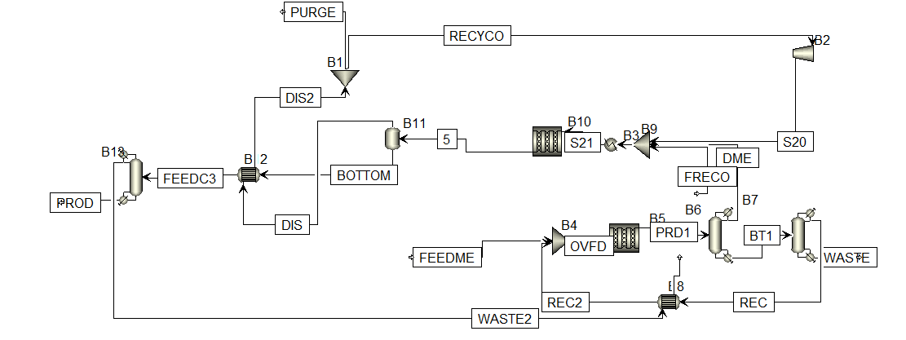

***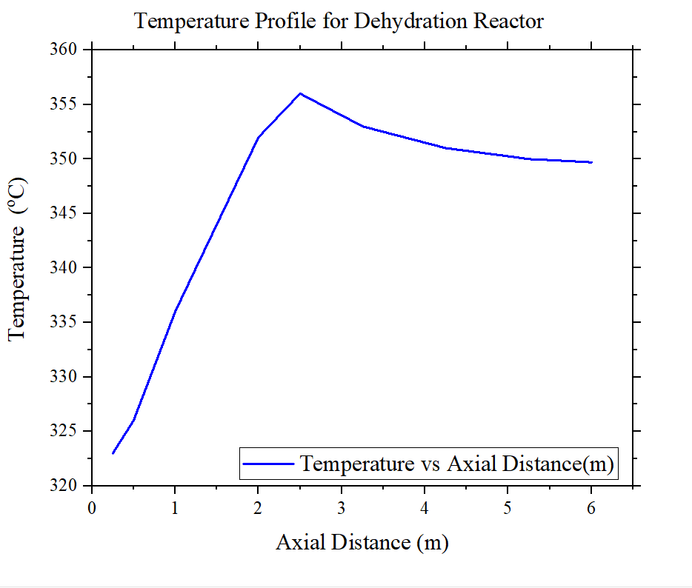*Figure S1.** Temperature profile for Dehydration Reactor

***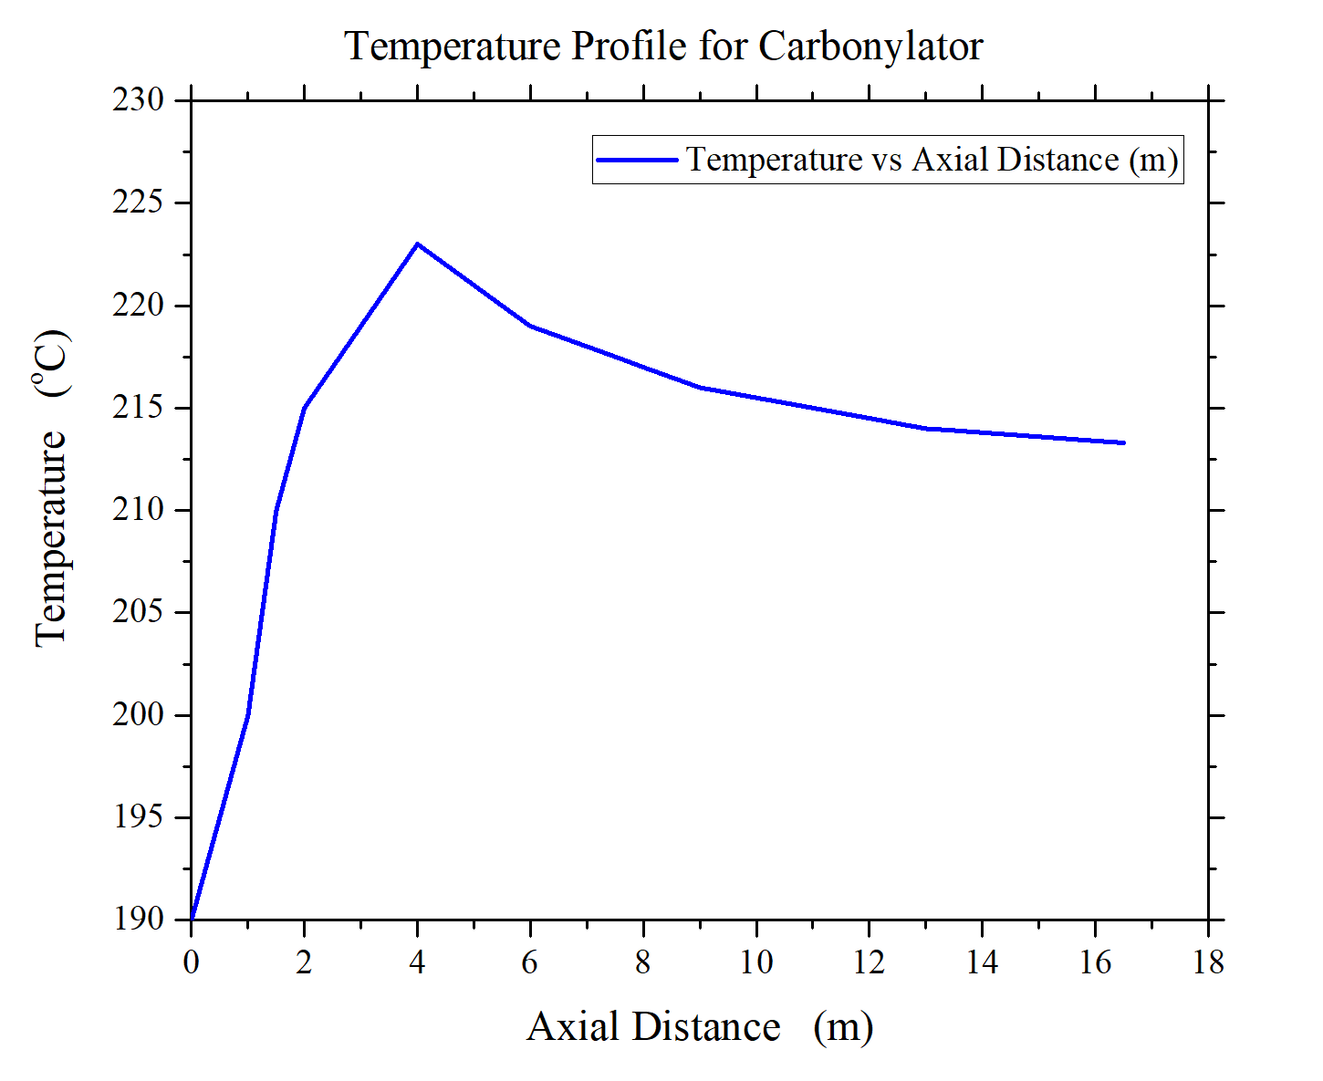*Figure S2.** Temperature profile for Carbonylation Reactor

***Appendix T: Cost of Manufacture Spreadsheet***

